MQXFS1c Magnetic Measurement Plan
Version 1, 4/12/17

Contents
1 Magnetic measurement goals for MQXFS1c 1
2 Facility and rotating probe 1
3 Reference parameters and conditions 2
4 Longitudinal scan at room temperature 3
5 Magnet Cool-down, check-ups and training 4
6 Field quality characterization 4
6.1 Accelerator cycle to nominal gradient 4
6.2 Z scan at nominal gradient 5
6.3 Z scan at ultimate gradient 6
6.4 Ramp-rate dependence 6
7 Z scan during warmup and at room temperature 7
8 References 8

Magnetic measurement goals for MQXFS1c

MQXFS1c uses the same coils as MQXFS1 and MQXFS1b. A full set of magnetic measurements were performed during previous tests. MQXFS1c features increased axial pre-load and reconfigured magnetic shims to correct for an error in the original configuration. In addition, MQXFS1c will provide an opportunity to commission two new PCB probes (details below). The main goals for MQXFS1c magnetic measurements are therefore: (a) to confirm that the new shim configuration provides the desired correction; (b) to check for any changes related to the axial pre-load increase; (c) to validate the new probes for future use in short models and long prototypes.

Facility and rotating probe

Feedback from previous tests:
In the first TC of MQXFS1, a 30-layer probe was used including a 110 mm and 220 mm PCB mounted on the same shaft. The main field signal from the 30-layer probe was found to saturate the amplifiers. An attenuator was used but found to distort the signals. In the second TC, a 2-layer probe including a 110 mm long and a 55 mm long PCB. This provided reliable data but with lower resolution.
For MQXFS1b, we used a modified version of the 30-layer probe, where the main field is extracted using only the first two layers, and the bucked signal is extracted from the full 30-layer. The 110 mm PCB (indicated as probe #1 in the following) will be used as reference for all measurements. The 220 mm signal (indicated as probe #2) will be acquired in parallel and used for calibration.
Plan for MQXFS1c:
Incorporating the lessons learned in previous tests, two new probes were developed for use in future short models and long prototypes. These probes feature a slightly adjusted length to better match the cable twist pitch (leading to a change in the step size for z scans, from 53.35 to 54.37 mm) and a two-layer design providing a signal strength that can be fed directly to the existing amplifiers and DAQ. One probe is meant for short models (will be referred to as FNAL probe) and one for long prototypes (will be referred to as BNL probe). Both probes still incorporate a (nominal) 110 mm PCB (#1) and a 220 mm PCB (#2). Both probes will be used in the MQXFS1c test, in order to cross-check and validate the results. For each measurement listed below, we specify which probe is to be used (FNAL, BNL, or both). The 54.37 mm step is chosen based on the 110 mm probe; for the 220 mm probe, the optimal step would be 54.47 mm.

Reference parameters and conditions

- Nominal ramp rate is 14 A/s.

- Currents and corresponding gradients for injection, nominal and ultimate level are specified in Table 1. Injection level was calculated as follows. G.inj = 132.6/7*0.45 = 8.5 T/m. Low current transfer function is 8.86 T/m/kA (Ref: MQXF design report v7, July 2015), therefore 0.96 kA for 8.5 T/m

Table 1 Reference current levels for magnetic measurements of MQXFS.
Current [kA] | Symbol | Gradient [T/m] | Remarks
0.1 | I.res | 0.9 | Reset level for pre-cycle
0.96 | I.inj | 8.5 | Injection level
6.0 | I.lim | 48.8 | Current limit (pre-training)
16.48 | I.nom | 132.6 | Nominal level
17.76 | I.ult | 143.2 | Ultimate level
21.5 | I.ssl | 171.0 | 1.9K Short Sample Limit

- An optimized profile for acceleration/deceleration at the beginning and end of each ramp needs to be defined (for each ramp rate) to minimize the impact on the multipole decay and to avoid current overshoot and the resulted ramp irregularity

- Pre-cycle parameters for measurements up to I.nom (or higher). A pre-cycle is applied to put the magnet into a reproducible state prior to the following measurements: accelerator cycle, stair-step measurements and ramp-rate dependence measurements.

  - The pre-cycle is defined as follows:

    - From 0 to I.nom at 14 A/s,
    - Hold for 300 s at I.nom,
    - Ramp down to I.res at 14 A/s
    - Hold for 0s at I.res
    - Ramp to I.inj at 14 A/s
    - [Hold at I.inj is treated as part of the measurement cycle]

  - The pre-cycle needs to be adapted for measurements limited to lower current (e.g. before training, if any). The modified pre-cycle is described in the corresponding sections.
  - For measurements requiring a pre-cycle, the pre-cycle needs to be repeated in the case of a spontaneous quench, prior to completing the measurement.

- The central location will be determined during the warm measurements and confirmed during the system checks phase by matching the transfer function dependence on z to design calculations and similar measurements taken during the magnet assembly.

The following sections describe the individual magnetic measurements to be performed.

Longitudinal scan at room temperature

- Goals:
  - Check the measurement system and probe behavior.
  - Determine the probe reference location with respect to the magnetic center, and the reference angle.
  - Compare the room-temperature measurements with those performed during the magnet assembly.

- Probe: both FNAL and BNL

- Conditions:
  - Magnet placed in the vertical cryostat, before start of cool-down
  - Current: ±10 A
  - Longitudinal locations refer to center of circuit #1 (circuit #2 data recorded in parallel)
  - Longitudinal locations: from z=-869.92 to z=+869.92, every 54.37 mm

Magnet Cool-down, check-ups and training

- No measurements are foreseen prior to, or during training quenches in TC2, unless required for measurement system checks.

Field quality characterization

Accelerator cycle to nominal gradient

- Goals:
  - Measure central field quality in conditions that approximate the machine cycle to nominal gradient
  - Assess stability at I.inj and changes in harmonics at the start of ramp
  - Assess stability of operation at I.nom
  - Assess reproducibility from cycle to cycle

- Probe: FNAL only

- Conditions:
  - Use circuit #1 at central location (circuit #2 data recorded in parallel)

- Measurement cycle (Fig. 3):

  - Perform standard pre-cycle
  - Hold 1000 s at I.inj
  - Ramp to I.nom at 14 A/s
  - Hold I.nom for 600 s
  - Ramp down to I.res at 14 A/s
  - Hold for 0s at I.res
  - Ramp to I.inj at 14 A/s
  - Repeat point 2 to 5 for two more times
  - Ramp down to zero

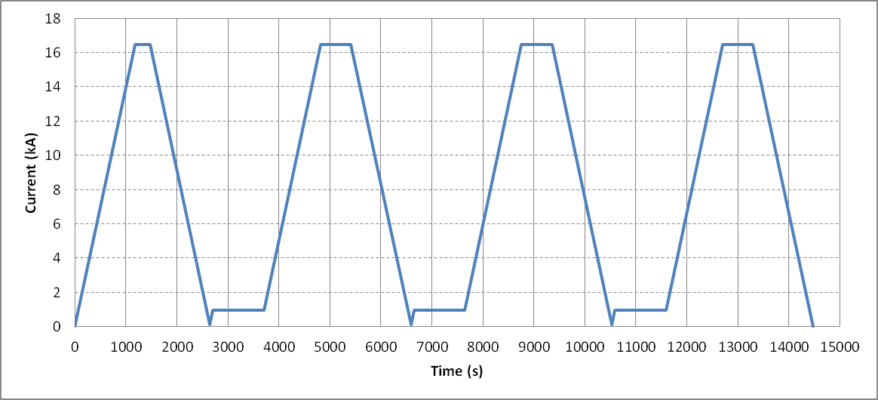
Figure 3: current profile for one accelerator cycle to nominal gradient.

Z scan at nominal gradient

- Goals:
  - Measure field quality variations along the magnet length

- Probe: both FNAL and BNL

- Conditions:
  - Longitudinal locations refer to center of circuit #1 (circuit #2 data recorded in parallel)
  - Longitudinal locations: from z=-869.92 to z=+869.92, every 54.37 mm

- Measurement cycle :

- Perform standard pre-cycle
- Hold 1000 s at I.inj
- Z-scan at I.inj
- Ramp to I.lim at 14 A/s
- Hold 300 s at I.lim
- Z-scan at I.lim
- Ramp to I.nom at 14 A/s
- Hold 300 s at I.nom
- Z-scan at I.nom
- Ramp down to zero

Z scan at ultimate gradient

- Goals:
  - Measure field quality variations along the magnet length at I.ult

- Probe: FNAL only, or both FNAL and BNL if time is available

- Conditions:
  - Longitudinal locations refer to center of circuit #1 (circuit #2 data recorded in parallel)
  - Longitudinal locations: from z=-869.92 to z=+869.92, every 54.37 mm

- Measurement cycle :

- Perform standard pre-cycle
- Hold 1000 s at I.inj
- Ramp to I.ult at 14 A/s
- Hold 300s at I.ult
- Z-scan at I.ult
- Ramp down to zero

Ramp-rate dependence

- Goals:
  - Measure eddy current harmonics at different ramp rates

- Probe: both FNAL and BNL

- Conditions:
  - Use circuit #1 at central location (circuit #2 data recorded in parallel)

- Measurement cycle (Fig. 5):

- Perform standard pre-cycle
- Hold 1000 s at I.inj
- Ramp to I.nom at 20 A/s
- Hold 600 s at I.nom
- Ramp to I.inj at 20 A/s
- Hold 600 s at I.inj
- Ramp to I.nom at 40 A/s
- Hold 600 s at I.nom
- Ramp to I.inj at 40 A/s
- Hold 600 s at I.inj
- Ramp to I.nom at 80 A/s
- Hold 600 s at I.nom
- Ramp to I.inj at 80 A/s
- Hold 600 s at I.inj
- Ramp to zero

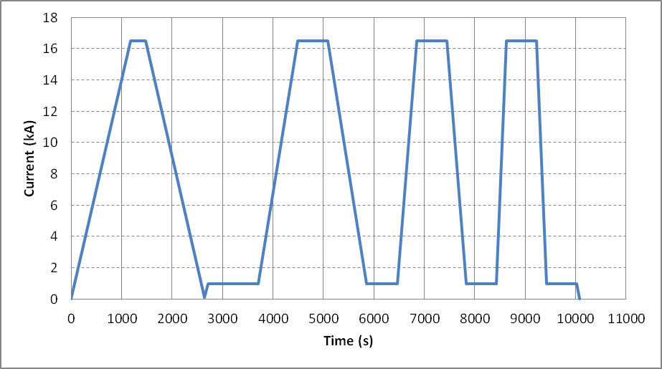
Figure 5: current profile for the ramp-rate dependence study

Z scan during warmup and at room temperature

- Allowed current levels as a function of temperature:

  - If the resolution at 10 A is acceptable, the same current will be used for measurements at all intermediate temperatures. To be confirmed after warm measurements in vertical positions.
  - If increased current is desirable, Table 2 shows the expected safe current limits as function of temperature, based on HQ experience. This will be verified for QXF by monitoring the coil strain gauges and voltage.

Table 2 Maximum current for different temperature intervals
Temp. (K) | Current (A)
200 – 295 | ± 15
100 – 200 | ± 20
< 100 | ± 30

- Goals:
  - Measure geometric harmonics at low current as a function of temperature

- Probe: FNAL only

- Conditions:

  - Default current 10 A. Maximum current as defined in section 6.
  - Longitudinal locations refer to center of circuit #1 (circuit #2 data recorded in parallel)
  - Longitudinal locations: from z=-869.92 to z=+869.92, every 54.37 mm

- Additional notes:

- Target one measurement soon after the magnet enters the normal state (~ 30 K) to obtain the geometric effect with maximum effect of preload from cooldown.
- External heating to expedite the warmup process should be off before and during the measurements to help reducing temperature gradient along the magnet.

References

- MQXFS1 and MQXFS1b Test plan page in LARP DocDB:
http://larpdocs.fnal.gov//LARP-public/DocDB/ShowDocument?docid=1079
http://larpdocs.fnal.gov//LARP-public/DocDB/ShowDocument?docid=1128

