QXFP03 Coil to Pole Shorts

Phase 1 – Discovering

7/20/2016

During the first cycle of Hipot tests (OD up) we noticed two shorts Coil to Pole:

Hipot failed at 10V/300V with leakage 68.5 μA.

R between coil and Pole segm #10 was 81 kΩ and R between Pole segm #1 (R1) and #2 (R2) (shorted togheter) was 185 kΩ.

7/21/2016

Pole segm #1 and #2 no longer in contact with each other and with the coil (R1=R2=Open).

Hipot Coil to Pole (first 9 Pole segms):

Hipot failed at 100V/300V with leakage 31 μA.

R1=Open R2=Open

Hipot Coil to Pole segm #2:

Hipot failed at 160V/300V with leakage 1266 μA.

R1=Open R2=190 kΩ

Hipot Coil to Pole segm #1:

Hipot failed at 180V/300V with leakage 76 μA.

R1=180 kΩ R2=20 MΩ

Hipot Coil to Pole segm #2:

Hipot failed at 40V/300V with leakage 11 μA.

R1=180 kΩ R2=Open
Phase 2 – First Investigation

Injecting 1 A in the coil and probing the VTs with a multimeter, we filled this table finding the position of the shorts (Err ±10 cm).

Table 1
 | Voltage (mV) | Position FROM LE Inner (m) | Distance from Previous (m)
A1 | 0.14 | 0.093487222
A2 | 0.2 | 0.133553174 | 0.040065952
A3 | 196 | 130.8821105 | 130.7485573
A4 | 255 | 170.2802968 | 39.39818631
A5 | 255.3 | 170.4806265 | 0.200329761
RE Short | 260.5 | 173.9530091 | 3.472382523
A6 | 260.9 | 174.2201154 | 0.267106348
A7 | 261.1 | 174.3536686 | 0.133553174
LE Short | 266 | 177.6257214 | 3.272052762
B8 | 266.75 | 178.1265458 | 0.500824402
B7 | 267 | 178.2934872 | 0.166941467
B6 | 272.6 | 182.0329761 | 3.739488871
B5 | 272.9 | 182.2333059 | 0.200329761
B4 | 278.3 | 185.8392415 | 3.605935697
B3 | 421 | 281.1294312 | 95.29018961
B2 | 606.3 | 404.8664468 | 123.7370157
B1 | 606.4 | 404.9332234 | 0.066776587

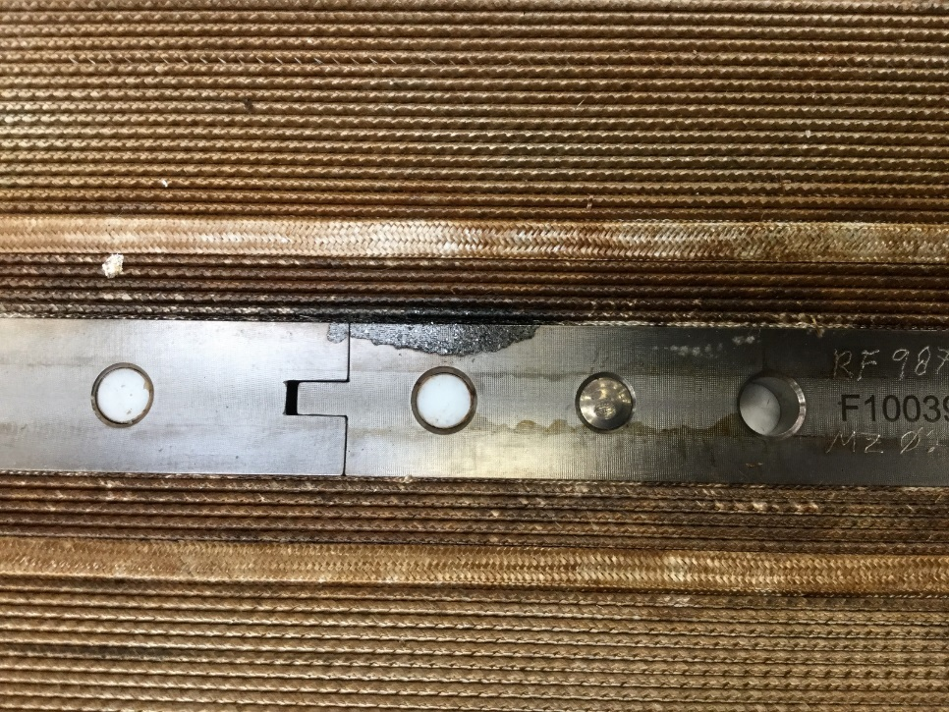
Figure 1: Pole Segm #10 – After Reaction
Regarding the RE short, visual inspection of the pictures (and further tests) brought us to find the short genesis: excess of binder. The position of the black spot is comparable with the short position (Table 1).

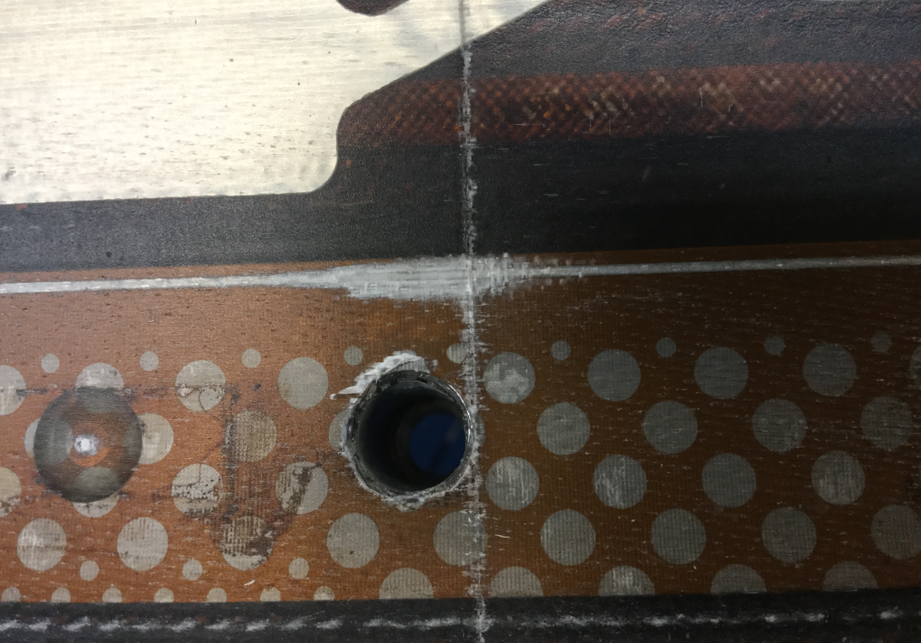
Figure 2: Pole Segm #1 – After Impregnation

Regarding the LE short, visual inspection of the coil brought us to find the problem: an excess of pressure during impregnation that cut the VT#A08 wire causing a short between coil and Pole segm #1 (maybe). The position of the high pressure point was 30 cm closer to LE than the measurement (Table 1). We decided to proceed with a repair attempt of the high pressure area.
Phase 3 – Repairing

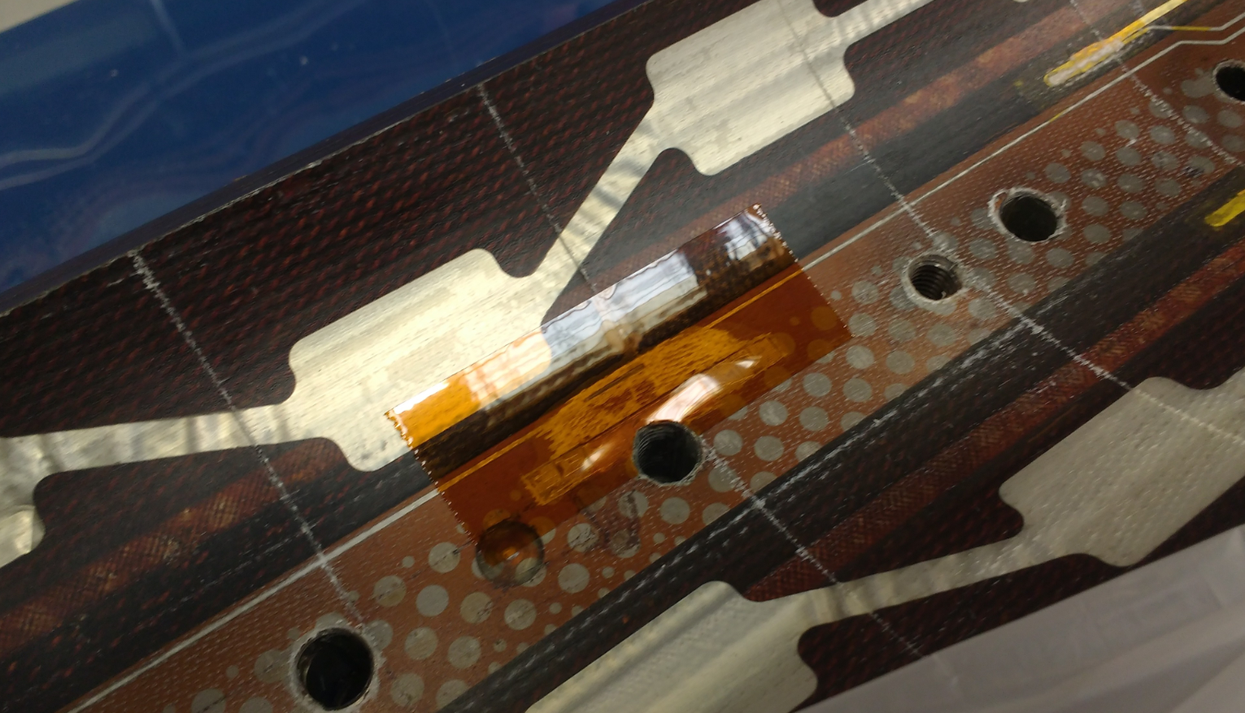
Figure 3: Pole Segm #1 – Short Repaired
We detached the trace from the pole and inserted a new sheet of Kapton between the trace (VT) and the pole.

The short disappeared: R1=Open R2=Open

8/11/2016

Hipot Coil to Pole segm #2:

Hipot 300V/300V with leakage 0.0 μA.

R1=Open R2=Open

Hipot Coil to Pole segm #1:

Hipot 300V/300V with leakage 0.0 μA.

R1=Open R2=Open

The LE short was fixed.
Phase 4 – Rediscovering

10/14/16

Coil in the shipping crate (OD up). Final electric checks. We measured the Coil to Pole segm resistances: R Pole segm 1 Inner to Coil 236 kΩ, R Pole segm 2 Inner to Coil 236 kΩ, R Pole segm 1 Outer to Coil 236 kΩ, R Pole segm 2 Outer to Coil 760 kΩ, Pole 1 and Pole 2 shorted on the Inner and opened on the Outer, Pole 1 Inner shorted with Pole 1 Outer and R between Pole 2 Inner and Outer 510 kΩ.

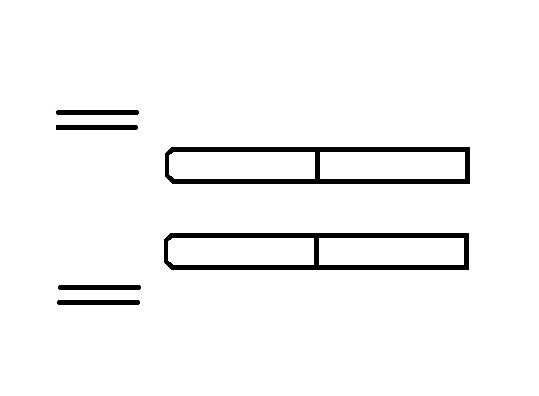
Open
Short
236 kΩ
236 kΩ
760 kΩ
236 kΩ
510 kΩ
Short
Coil
Coil
IL
OL
The LE short is back (and the RE short is now 101 kΩ).
Phase 5 – Second Investigation

The same day we moved the coil to the rolling table and we rolled it in order to inspect the IL with the Kapton repair (ID up).
There were no visible damages on the tape. No changes checking the resistance while pocking the Kapton.
Another voltage measurement (like the Table 1 one) was performed late that day and results were:
B08 266.4 mV, LE Short 265.6 mV and A07 260.7 mV. This means short at 3.3 m from A07 and 54 cm from B08. Same result as we had in Table 1.

10/17/16

The morning R checking gave the same results as Friday (10/14). After the removal of the top part of the rolling arcs and some minor activities, the situation became:

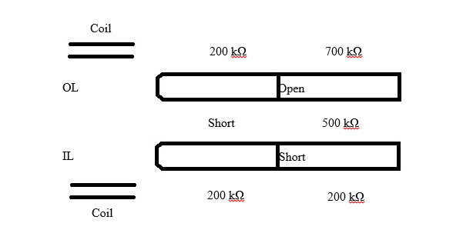
760 kΩ
510 kΩ
236 kΩ
Open
Open
Open

Another voltage check (this time more accurate) confirmed again the position of the short. Removing the Kapton tape from the VT08 (at the end we put it back) was possible to measure also that VT voltage.

Table 2 – Placing the Multimeter Low Voltage probe on VTA07 (0 mV) was possible to find more accurate results.
mV | Short | A08 | B08
 | 4.8849 | 5.253 | 5.681
 | 4.8896 | 5.2419 | 5.6924
 | 4.8934 | 5.2391 | 5.6867
 | 4.8863 | 5.2386 | 5.6871
 | 4.8914 | 5.238 | 5.6814
 | 4.8878 | 5.2367 | 5.6818
 | 4.8849 | 5.2331 | 5.6857
 | 4.89 | 5.2385 | 5.6866
Average | 4.888538 | 5.239863 | 5.685338
St Dev | 0.003097 | 0.005855 | 0.003843
Min | 4.879248 | 5.222297 | 5.673807
Max | 4.897827 | 5.257428 | 5.696868
A08 Position (Figure 4) | 68 | cm
A07 Position (Figure 5) | 420 | cm
A07-A08 | 352 | cm
 | 67.17734 | cm/mV
Distance Short - A08 | Min | 23.04513 | cm | Position (Figure 6) | 91 | cm
 | Max | 24.15703 | cm | Position (Figure 6) | 92 | cm
Distance Short - A07 | Min | 327.7749 | cm | Position (Figure 6) | 92 | cm
 | Max | 329.023 | cm | Position (Figure 6) | 91 | cm

Watching Figure 7 a little black spot can be seen. An excess of binder (not severe like the RE Short one from Figure 1) can explain the cause of this short.
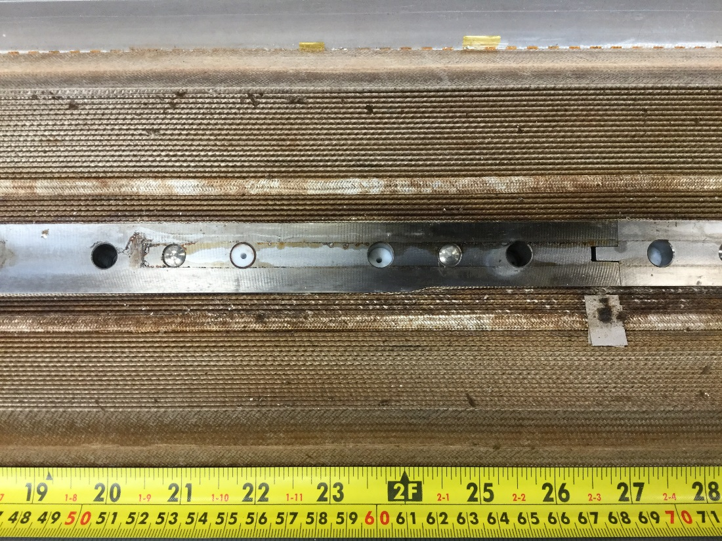
Figure 4: A08 Position - 68 cm

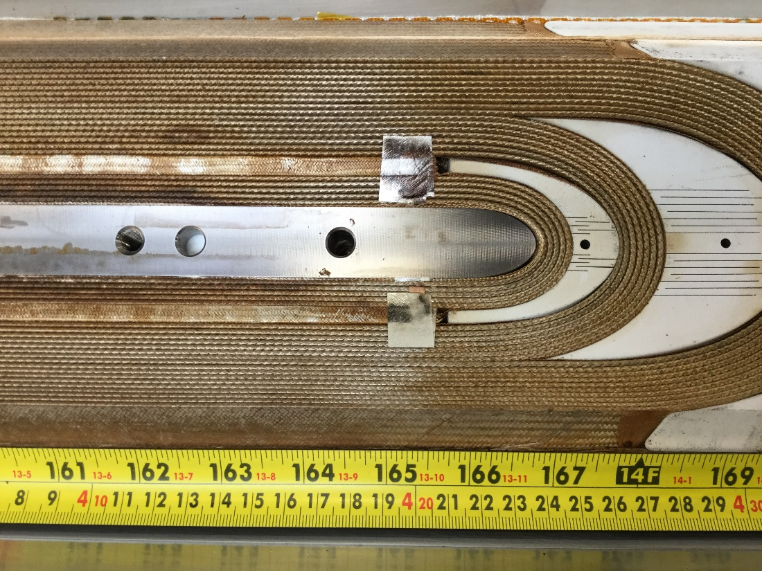
Figure 5: A07 Position - 420 cm
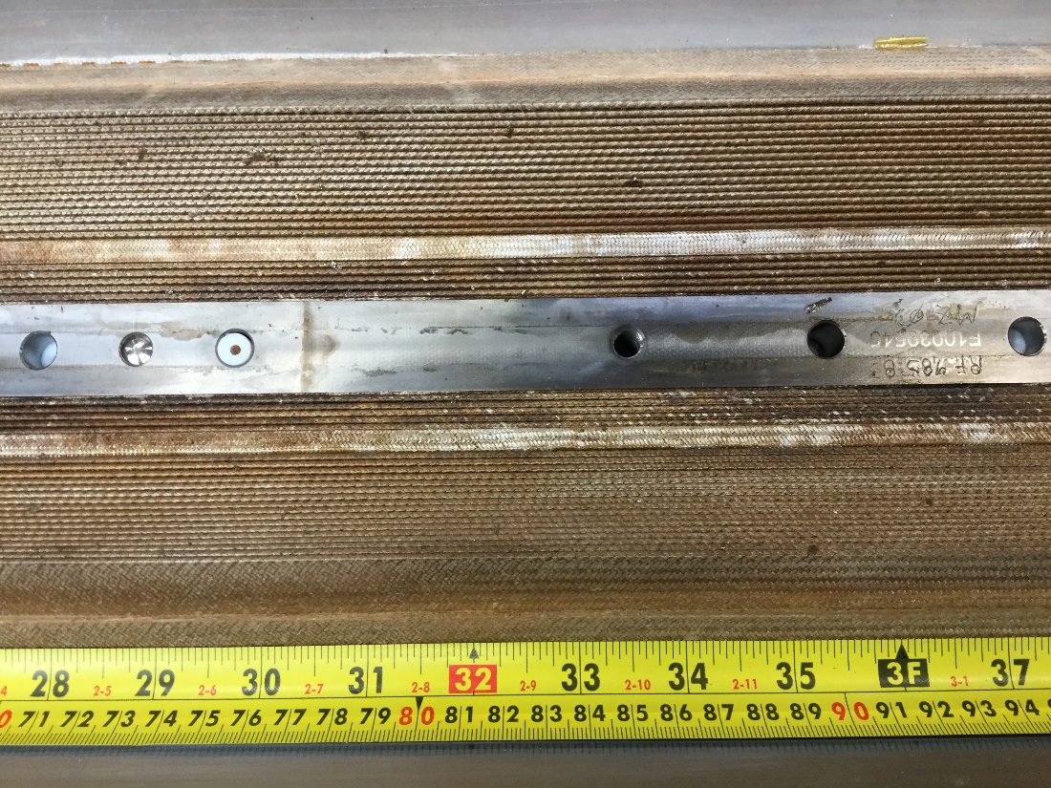
Figure 6: LE Short Position - Between 91 cm and 92 cm.
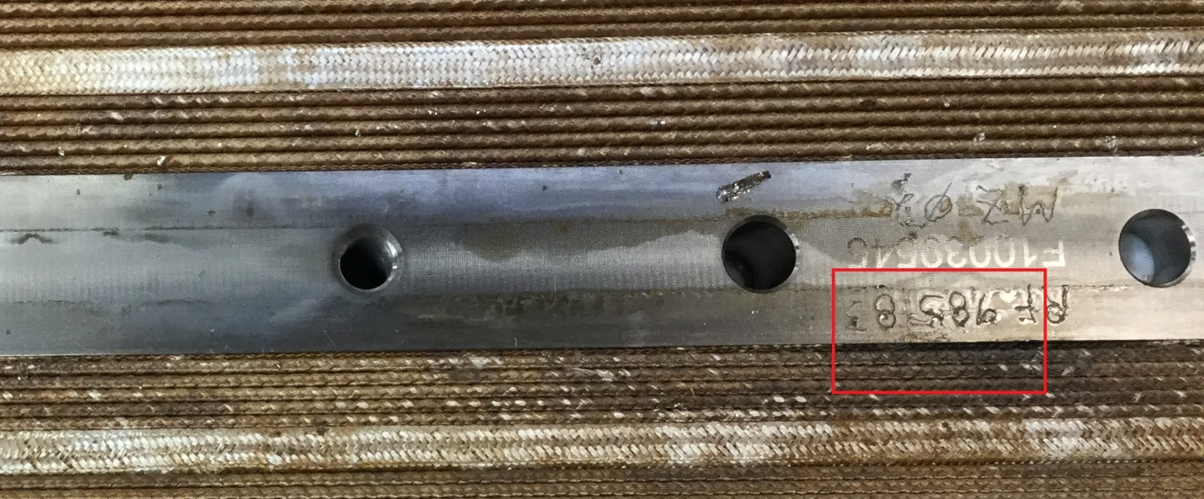
Figure 7: LE Short Area Zoom.

Enriched by this new knowledge (the shorts are two, they cannot be repaired, one is close to LE and the other close to RE) we decided to check the dielectric strength of the Pole segm gaps between Pole segm 2 and Pole segm 10. Two shorts are dangerous if they can communicate. The drop in potential between LE and RE of the same turn during a quench can arrive to ~50V. We decided to check each gap with a 100V Hipot.
The result was:
All the gaps tested (2-3, 3-4, 4-5, 5-6, 6-7, 7-8, 8-9, 9-10) survived the 100V Hipots with a maximum leakage current of 0.3 μA.
Phase 6 – Final News

10/20/2016

We rolled the Coil (OD up) and, checking very fast the status of the resistances, we recorded this:

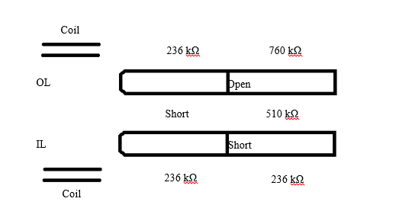
236 kΩ
510 kΩ
760 kΩ
1000 kΩ

1200 kΩ
1200 kΩ

We tried to “counter-bend” the Coil LE (pushing a little from the ID to the OD) and the situation came back as before (no readable R on the first Pole segm). After some minutes we measured again and noting changed. So we had:

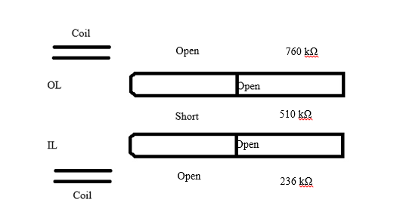
236 kΩ
510 kΩ
760 kΩ
Conclusions

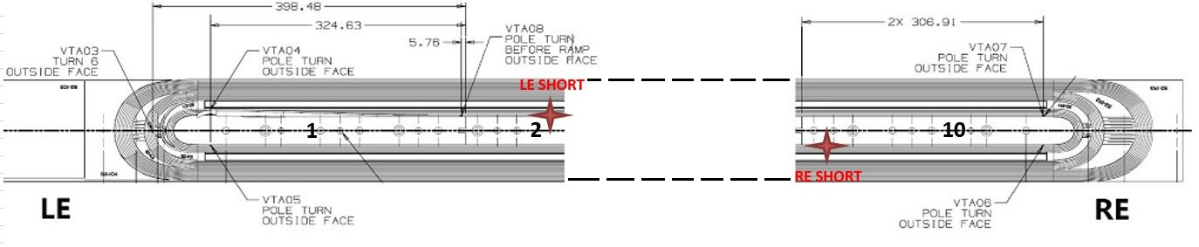
Figure 1: Inner layer (the picture is from Winding traveler – so it’s like to see the coil IL with the OL facing up).

Now (10/20/2016) QXFP03 has two Coil to Pole shorts:
- 236 kΩ in Pole segm #2, T-side, between VT-A08 and VT-A07, precisely at 24 cm from VT-A08 location and 329 cm from VT-A07 location. (Table 2)
- 101 kΩ in Pole segm #10, NT-side, between VT-A05 and VT-A06, ~347 cm from VT-A05 location and ~27 cm from VT-A06 location. (Table 1)

They cannot communicate thanks to 8 gaps that can stand 100V each. In fact, we performed 100V Hipot tests between Pole segm#2 and #3, #3 and #4, #4 and #5, #5 and #6, #6 and #7, #7 and #8, #8 and #9, #9 and #10 and they were all successful (leakage current less than 0.3 µA).

The Pole segments in the middle (#3,4,5,6,7,8,9) where connected together and the 300V Hipot test between them and the Coil was successful (the leakage current was 0.3 µA).

There are good chances that both shorts were caused by excess of binder and carbon paths between Coil and Pole.

The gap between Pole segm #1 and #2 (Inner) is open or close depending on position and bending of the Coil.

We have no clues to be sure that there was a short in Pole segm #1 (I have never detected it with voltage measurement), but we have no clues neither to be sure that there wasn’t a short in Pole segm #1 (after the repairing the Pole segm #1 short disappear and the Pole segm #1 and #2 survived 300V Hipot). The only think that we can say is that now there is not a short in Pole segm #1.
Part of the uncertainty comes from the fact that during the 7/21/16 resistances checks I didn’t take different measurements for IL and OL Pole segms.

Add 4 VT on Pole segms #1, #2, #5 and #10 can be a good idea. This will allow monitoring of the shorts propagation after the magnet assembly and after the cool down.

For a better future:

-keep attention to the binder application (already in progress)
-keep track of the high pressure areas generated by the increase in insulation thickness (already in progress)
-during the continuity checks Pole to Coil, check (if possible) Outer Pole segms to Coil, Inner Pole segms to Coil, Outer Pole segm to Inner Pole segm and adjacent Pole segms

10/24/2016

After one weekend sitting on the Shipping Mandrel:

240 kΩ
340 kΩ
580 kΩ

