MQXFS1b Magnetic Measurement Plan
Version 1, 7/8/16

Contents
1 Magnetic measurement goals for MQXFS1b 1
2 Facility and rotating probe 1
3 Reference parameters and conditions 2
4 Longitudinal scan at room temperature 3
5 Magnet Cool-down, check-ups and training 3
6 Field quality characterization 3
6.1 Stair-step measurement 4
6.2 Accelerator cycle to ultimate current (with long injection plateau on third cycle) 5
6.3 Z scan at nominal gradient 6
6.4 Z scan at ultimate gradient 7
6.5 Effect of reset current 7
7 Z scan during warmup and at room temperature 8
8 References 9

Magnetic measurement goals for MQXFS1b

MQXFS1b uses the same coils as MQXFS1 where a full set of magnetic measurements were performed during two thermal cycles. The main goal for MQXFS1b magnetic measurements is to confirm the effect of the magnetic shims introduced to correct the normal and skew sextupole, and to check for any effects due to a pre-load increase. We also plan to perform an accelerator cycle with long injection plateau to better assess the persistent current decay (this study was not performed in MQXFS1 due to lack of time)

Facility and rotating probe

Two probes were used in MQXFS1: and a 2-layer probe including a 110 mm long and a 55 mm long PCB. Radius is 50.5 mm for both.
In the first TC of MQXFS1, a 30-layer probe was used including a 110 mm and 220 mm PCB mounted on the same shaft. The main field signal from the 30-layer probe was found to saturate the amplifiers. An attenuator was used but found to distort the signals. In the second TC, a 2-layer probe including a 110 mm long and a 55 mm long PCB. This provided reliable data but with lower resolution.
For MQXFS1b, we plan to use a modified version of the 30-layer probe, where the main field is extracted using only the first two layers, and the bucked signal is extracted from the full 30-layer. The 110 mm PCB (indicated as probe #1 in the following) will be used as reference for all measurements. The 220 mm signal (indicated as probe #2) will be acquired in parallel and used for calibration.

Reference parameters and conditions

- Nominal ramp rate is 14 A/s..

- Currents and corresponding gradients for injection, nominal and ultimate level are specified in Table 1. Injection level was calculated as follows. G.inj = 132.6/7*0.45 = 8.5 T/m. Low current transfer function is 8.86 T/m/kA (Ref: MQXF design report v7, July 2015), therefore 0.96 kA for 8.5 T/m

Table 1 Reference current levels for magnetic measurements of MQXFS.
Current [kA] | Symbol | Gradient [T/m] | Remarks
0.1 | I.res | 0.9 | Reset level for pre-cycle
0.96 | I.inj | 8.5 | Injection level
6.0 | I.lim | 48.8 | Current limit (pre-training)
16.48 | I.nom | 132.6 | Nominal level
17.76 | I.ult | 143.2 | Ultimate level
21.5 | I.ssl | 171.0 | 1.9K Short Sample Limit

- An optimized profile for acceleration/deceleration at the beginning and end of each ramp needs to be defined (for each ramp rate) to minimize the impact on the multipole decay and to avoid current overshoot and the resulted ramp irregularity

- Pre-cycle parameters for measurements up to I.nom (or higher). A pre-cycle is applied to put the magnet into a reproducible state prior to the following measurements: accelerator cycle, stair-step measurements and ramp-rate dependence measurements.

  - The pre-cycle is defined as follows:

    - From 0 to I.nom at 14 A/s,
    - Hold for 300 s at I.nom,
    - Ramp down to I.res at 14 A/s
    - Hold for 0s at I.res
    - Ramp to I.inj at 14 A/s
    - [Hold at I.inj is treated as part of the measurement cycle]

  - The pre-cycle needs to be adapted for measurements limited to lower current (before training). The modified pre-cycle is described in the corresponding sections.
  - For measurements requiring a pre-cycle, the pre-cycle needs to be repeated in the case of a spontaneous quench, prior to completing the measurement.
- The central location will be determined during the warm measurements and confirmed during the system checks phase by matching the transfer function dependence on z to design calculations and similar measurements taken during the magnet assembly.

The following sections describe the individual magnetic measurements to be performed.

Longitudinal scan at room temperature

- Conditions:
  - Magnet placed in the vertical cryostat, before start of cool-down
  - Current: ±10 A
  - Longitudinal locations refer to center of probe #1 (probe #2 data recorded in parallel)
  - Longitudinal locations: from z=-853.6 to z=+853.6, every 53.35 mm
- Goals:
  - Check the measurement system and probe behavior.
  - Determine the probe reference location with respect to the magnetic center, and the reference angle.
  - Compare the room-temperature measurements with those performed during the magnet assembly.

Magnet Cool-down, check-ups and training

- No measurements are foreseen prior to, or during training quenches in TC2, unless required for measurement system checks.

Field quality characterization

Stair-step measurement

- Goals:
  - Measure static field errors at various current intervals

- Conditions:
  - Use probe #1 at central location (probe #2 data recorded in parallel)

- Measurement cycle:
- Perform standard pre-cycle
- Hold 1000 s at I.inj
- Ramp to I.ult in steps (as defined in Table 3). Ramp rate 14 A/s
- Hold 60 s at each step
- Ramp to 17.9 kA (no measurements)
- Ramp down to I.inj in same steps
- Ramp down to zero

Table 3 Current steps for stair step measurement
Step # | Current (kA)
1 | I.inj
2 | 1.5
3 | 2.0
4 | 2.5
5 | 3.0
6 | 4
7 | 5
8 | 6
9 | 7
10 | 8
11 | 9
12 | 10
13 | 11
14 | 12
15 | 13
16 | 14
17 | 15
18 | 16
19 | I.nom
20 | I.ult
21 | 17.9

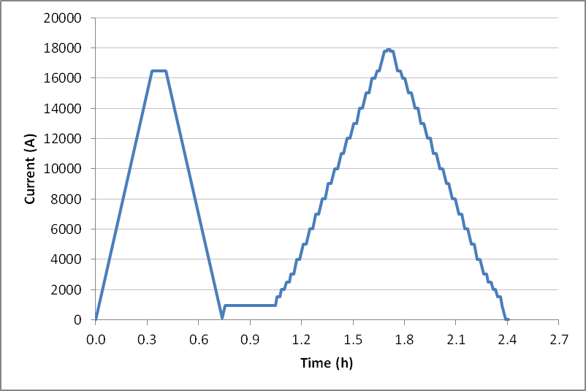

Fig. 7 Current steps for stair step measurement

Accelerator cycle to ultimate current (with long injection plateau on third cycle)

- Goals:
  - Measure central field quality in conditions that approximate the machine cycle to ultimate gradient
  - Confirm operation at I.ult
  - Assess reproducibility from cycle to cycle
  - Assess persistent decay time constant using a longer injection plateau (6000 s)

- Conditions:
  - Use probe #1 at central location (probe #2 data recorded in parallel)

- Measurement cycle (Fig. 8):

- Perform standard pre-cycle
- Hold 1000 s at I.inj
- Ramp to I.ult at 14 A/s
- Hold I.ult for 600 s
- Ramp down to I.res at 14 A/s
- Hold for 0s at I.res
- Ramp to I.inj at 14 A/s
- Hold 1000 s at I.inj
- Ramp to I.ult at 14 A/s
- Hold I.ult for 600 s
- Ramp down to I.res at 14 A/s
- Hold for 0s at I.res
- Ramp to I.inj at 14 A/s
- Hold 6000 s at I.inj
- Ramp to I.ult at 14 A/s
- Hold I.ult for 600 s
- Ramp down to I.res at 14 A/s
- Hold for 0s at I.res
- Ramp to I.inj at 14 A/s
- Ramp down to zero

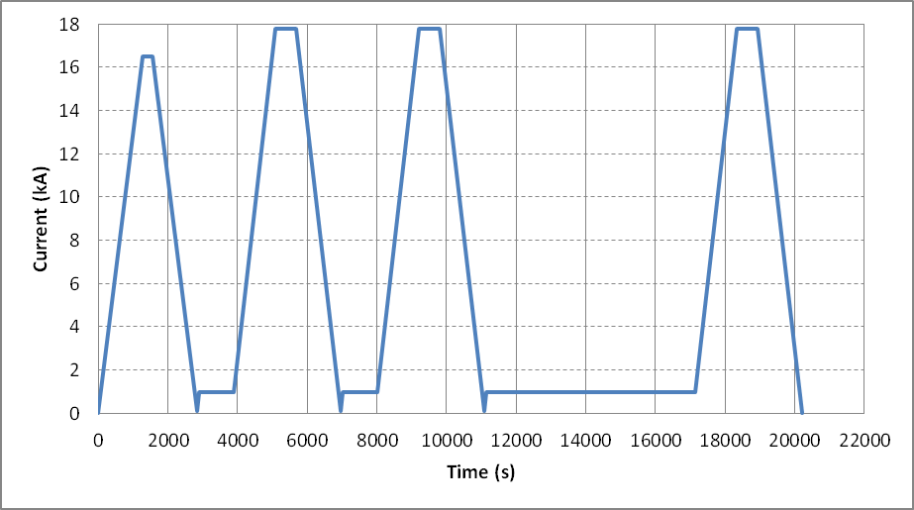

Figure 8: current profile for accelerator cycle to ultimate gradient

Z scan at nominal gradient

- Goals:
  - Measure field quality variations along the magnet length

- Conditions:
  - Longitudinal locations refer to center of probe #1 (probe #2 data recorded in parallel)
  - Longitudinal locations: from z=-853.6 to z=+853.6, every 53.35 mm

- Measurement cycle :

- Perform standard pre-cycle
- Hold 1000 s at I.inj
- Z-scan at I.inj
- Ramp to I.lim at 14 A/s
- Hold 300 s at I.lim
- Z-scan at I.lim
- Ramp to I.nom at 14 A/s
- Hold 300 s at I.nom
- Z-scan at I.nom
- Ramp down to zero

Z scan at ultimate gradient

- Goals:
  - Measure field quality variations along the magnet length at I.ult

- Conditions:
  - Longitudinal locations refer to center of probe #1 (probe #2 data recorded in parallel)
  - Longitudinal locations: from z=-853.6 to z=+853.6, every 53.35 mm

- Measurement cycle :

- Perform standard pre-cycle
- Hold 1000 s at I.inj
- Ramp to I.ult at 14 A/s
- Hold 300s at I.ult
- Z-scan at I.ult
- Ramp down to zero

Effect of reset current

- Goals:
  - Measure effect of reset current on persistent current harmonics at injection and subsequent ramp

- Conditions:
  - Use probe #1 at central location (probe #2 data recorded in parallel)

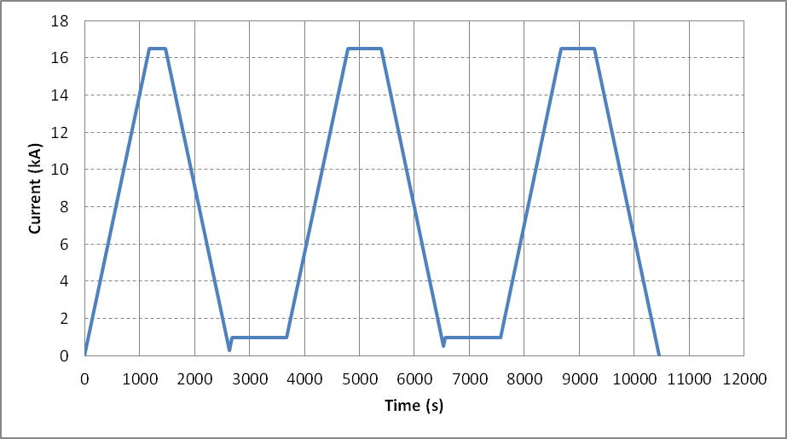
Figure 4: current profile for reset current study

- Measurement cycle (Fig. 4):

- Ramp from 0 to I.nom at 14 A/s,
- Hold for 300 s at I.nom,
- Ramp down to 300 A at 14 A/s
- Hold for 0s at 300 A
- Ramp to I.inj at 14 A/s
- Hold 1000s at I.inj
- Ramp to I.nom at 14 A/s
- Hold I.nom for 600 s
- Ramp down to 500 A at 14 A/s
- Hold for 0s at 500 A
- Ramp to I.inj at 14 A/s
- Hold 1000s at I.inj
- Ramp to I.nom at 14 A/s
- Hold I.nom for 600 s
- Ramp down to zero at 14 A/s

Z scan during warmup and at room temperature

- Allowed current levels as a function of temperature:

  - If the resolution at 10 A is acceptable, the same current will be used for measurements at all intermediate temperatures. To be confirmed after warm measurements in vertical positions.
  - If increased current is desirable, Table 2 shows the expected safe current limits as function of temperature, based on HQ experience. This will be verified for QXF by monitoring the coil strain gauges and voltage.

Table 2 Maximum current for different temperature intervals
Temp. (K) | Current (A)
200 – 295 | ± 15
100 – 200 | ± 20
< 100 | ± 30

- Goals:
  - Measure geometric harmonics at low current as a function of temperature

- Conditions:

  - Default current 10 A. Maximum current as defined in section 6.
  - Longitudinal locations refer to center of probe #1 (probe #2 data recorded in parallel)
  - Longitudinal locations: from z=-853.6 to z=+853.6, every 53.35 mm

- Additional notes:

- Target one measurement soon after the magnet enters the normal state (~ 30 K) to obtain the geometric effect with maximum effect of preload from cooldown.
- External heating to expedite the warmup process should be off before and during the measurements to help reducing temperature gradient along the magnet.

References

- MQXF Test plan page in LARP DocDB:
http://larpdocs.fnal.gov//LARP-public/DocDB/ShowDocument?docid=1079

