MQXFS1 Thermal Cycle 2 Protection Studies Plan
Version 2, 4/7/2016

Contents
1 Protection studies goals for MQXFS1 TC2 1
2 Protection studies overview 2
3 Reference parameters and conditions 3
4 During magnet cool-down 4
5 Protection system check-out (120 mOhm dump resistor, no delay, 4.5 or 1.9 K) 4
6 Heater delays before training (30 mΩ dump resistor, no delay; 1.9 K) 4
7 During training 4
8 After training: higher priority studies with T_{hot} < 200 K 5
8.1 Minimum power density to quench, part 1 5
8.2 Protection heater delays, part 1 5
8.3 Fast extraction study, part 1 6
9 After training – additional studies with lower priority and/or T_{hot} > 200 K (but <350 K) 7
9.1 Minimum power density to quench, part 2 7
9.2 Protection heater delays, part 2 7
9.3 Fast extraction study, part 2 8
9.4 Quench Integral 9
9.5 Failure scenario studies 9
10 Splice resistance measurements 9
11 Measurements during warmup and at room temperature 9
12 References 9

Protection studies goals for MQXFS1 TC2

During the first thermal cycle, MQXFS1 surpassed the ultimate current, and fully retained this level after a thermal cycle. Therefore, we do not need to consider the scenarios in which the magnet is limited to lower current levels.

In order to optimize the schedule, the test plan is subdivided in high priority tests (to be performed first) and low priority tests (time permitting).

Protection studies are also organized according to the potential risk associated with them. For the moment this is based on the estimated hot spot temperature that might be achieved. Three ranges are defined based on MQXF design calculations and experience from HQ testing:

- Training: T_{hot}<150 K (goal)
- General protection studies: T_{hot}<200 K
- Special protection studies: T_{hot}<350 K

A preliminary estimate of the MIITs associated with these temperature ranges is shown in Fig. 1. These ranges will have to be reassessed during the test, in particular to confirm that the temperature and MIITs during training can actually be maintained below the target values. High MIITs studies (T_{hot}>350K) are not foreseen for this test.

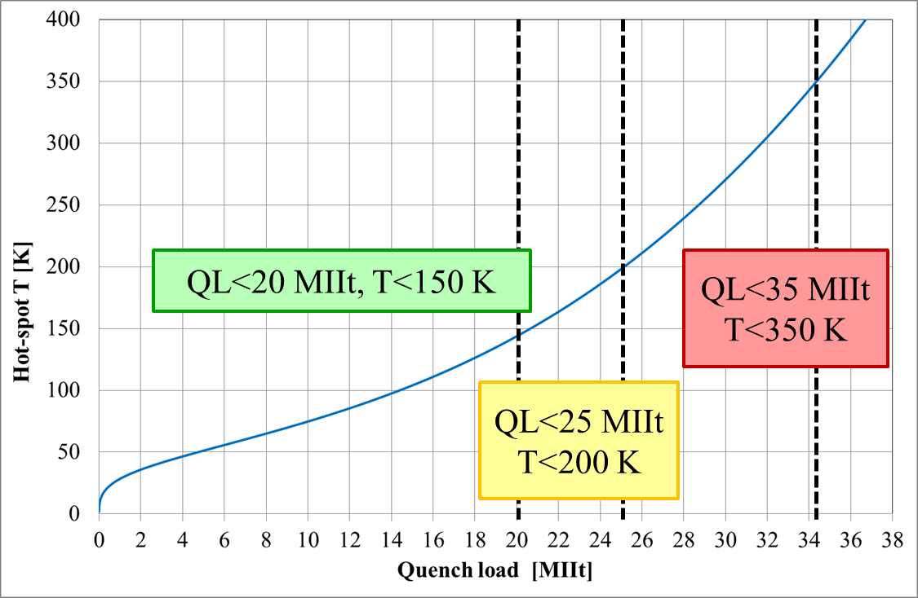

Fig. 1: Defined temperatures ranges and corresponding estimated MIITs ranges

Protection studies overview

This section provides an overview of the planned protection studies for each of the scenario and phases considered in the test plan:
- System and magnet checks below 6 kA
- Confirm heater functionality/performance and firing parameters
- During training
- Protection delays are normally set to zero and may be increased up to 10 ms for selected quenches in order to study propagation velocities, provided that sufficient margin can be verified to avoid exceeding the 150 K limit.
- After training: higher priority studies with T_{hot} < 200 K
  - Minimum heater power density to quench, part 1 (Section 8.1)
  - Protection heater delays, part 1 (Section 8.2)
  - Fast extraction studies, part 1 (Section 8.3)
- After training: additional studies with either lower priority or T_{hot} > 200 K (but < 350 K)
  - Minimum heater power density to quench, part 2 (Section 9.1)
  - Protection heater delays, part 2 (Section 9.2)
  - Fast extraction studies, part 2 (Section 9.3)
  - Quench integral (Section 9.4)
  - Failure scenario studies (Section 9.5)

Reference parameters and conditions

- Currents and corresponding gradients for injection, nominal and ultimate level are specified in Table 1. Short sample estimates (based on weighted average) and RRR from witness samples are provided in Table 2 and 3.

Table 1: reference current levels for MQXFS test.
Current [kA] | Symbol | Gradient [T/m] | Remarks
0.96 | I.inj | 8.5 | Injection level
16.48 | I.nom | 132.6 | Nominal level
17.76 | I.ult | 143.2 | Ultimate level
6.0 | I.lim | 48.8 | Current limit (pre-training)

Table 2: short sample estimates for MQXFS test.
Coil | 103 | 104 | L03 | L05
I_{ss} [kA] @ 1.9K | 21.5 | 21.8 | 22.28 | 21.84
I_{ss} [kA] @ 4.3K | 19.55 | 19.8
I_{ss} [kA] @ 4.5K |  |  | 20.12 | 19.72

Table 3: Coil RRR from witness samples.
Coil | 103 | 104 | L03 | L05
# samples (XS) | 3 | 3 | 6 | 6
RRR - weighted average [*]
RRR - simple average | 176 | 158
RRR - minimum | 164 | 146 | 232 | 347
RRR - maximum | 186 | 172 | 432 | 604
[*] Definition of weighted average

During magnet cool-down

- RRR measurements during cool down not required in TC2

Protection system check-out (120 mOhm dump resistor, no delay, 4.5 or 1.9 K)

- Goal: confirm proper operation of protection systems
- Quench Heater setup: All outer layer high field heaters and inner layer heaters connected. Outer layer low field heaters not connected in order to deliver sufficient power density.
- Schedule: one provoked quenches at 5 kA (30% nominal current). Measure delay to quench. Check signals for any signs of insulation failures.

Heater delays before training (30 mΩ dump resistor, no delay; 1.9 K)

- Not performed in TC2 (this test needs to be performed on virgin coils)

During training

- Standard setting: dump configuration: 30 mΩ, HFU settings as determined during provoked quenches, no delays to heaters and dump upon detection of quench
- Monitor MIITs, consider increasing the delays up to 10 ms to study propagation, if sufficient margin can be confirmed

After training: higher priority studies with T_{hot} < 200 K

The main plan includes general protection studies (with expected peak temperature below 200 K). Reference current levels for these studies are given in Table 4. The 20%, 50%, 80% and 100% points correspond to the ones used for the MQXFS1 mirror test. Points at 10% and 30% (1.65 kA and 4.94 kA) are added for a more complete assessment of the heater performance at low current, which is becoming more critical with the more recently proposed protection schemes in the accelerator.

Table 4: reference current levels for heaters/protection studies
Current [kA] | 1.65 | 3.30 | 4.94 | 8.24 | 13.18 | 16.48
I/I_{nom} | 0.1 | 0.2 | 0.3 | 0.5 | 0.8 | 1.0

Minimum power density to quench, part 1

- Goal: Find minimum heater power density needed to start a quench for different current levels (Table 4)
- Procedure: a single heater is fired at gradually increasing power, while the other heaters and dump are in protection mode
- Schedule:
  - Use C=19.2 mF
  - High priority section only includes CERN heaters (MQXF baseline). All three heater designs are included (OL high field, OL low field, IL)

Protection heater delays, part 1

- Goal: measure the delay from heater firing to start of quench for different current levels (Table 5) and power density (based on results of 8.1)
- Procedure: manually fire a test heater circuit while other heaters are protecting the magnet, measure delay to quench, then trigger 30 mΩ energy extraction (not delayed) to minimize cryogenic recovery time
- Schedule:
  - Current levels, capacitance and voltage from Table 5
  - Repeat for each type of heaters (high field outer, low field outer, inner. CERN design only (MQXF baseline) included in high priority section.
  - Reproducibility of results for nominally identical heaters from different coils is included in the lower priority section
Table 5a: Proposed current levels and HFU charging voltage and capacitance values for CERN-design outer high-field heater strip tests
CERN Outer HF QH | Current [kA] and I/I_{nom}
HFU | 1.65 | 3.30 | 4.94 | 8.24 | 13.18 | 16.48
 | 0.1 | 0.2 | 0.3 | 0.5 | 0.8 | 1.0
C=19.2 mF, U=150 V
C=19.2 mF, U=200 V

Table 5b: Proposed current levels and HFU charging voltage and capacitance values for CERN-design outer low-field heater strip tests
CERN Outer LF QH | Current [kA] and I/I_{nom}
HFU | 1.65 | 3.30 | 4.94 | 8.24 | 13.18 | 16.48
 | 0.1 | 0.2 | 0.3 | 0.5 | 0.8 | 1.0
C=19.2 mF, U=160 V
C=19.2 mF, U=200 V

Table 5c: Proposed current levels and HFU charging voltage and capacitance values for CERN-design inner heater strip tests
CERN Inner QH | Current [kA] and I/I_{nom}
HFU | 1.65 | 3.30 | 4.94 | 8.24 | 13.18 | 16.48
 | 0.1 | 0.2 | 0.3 | 0.5 | 0.8 | 1.0
C=19.2 mF, U=80 V
C=19.2 mF, U=150 V

Fast extraction study, part 1

- Procedure: manually trigger the quench detection, which triggers an energy extraction with a certain value of resistance; no heaters triggered; no quench, or only quench-back, expected
- Discharge at different current levels and with different resistance will provide information about the magnet dynamic behavior and quench back
- For these tests, quench load limited to <20 MIIt (T_{hot}<150 K) and peak voltage limited to <900 V
- Schedule: from Table 6.

Table 6: Expected initial current change for the proposed current and energy-extraction resistance values
Peak dI/dt [kA/s] | Current [kA] and I/I_{nom}
 | 1.65 | 3.30 | 4.94 | 8.24
R_EE [mΩ] | 0.1 | 0.2 | 0.3 | 0.5
5 | 0.7 | 1.3 | NO | NO
30 | 4.0 | 8.0 | 16.1 | 20.1
90 | 12.0 | 24.1 | 48.2 | 60.2

After training – additional studies with lower priority and/or T_{hot} > 200 K (but <350 K)

Minimum power density to quench, part 2 (LARP heaters, reproducibility, HFU capacitance settings)

- Goal: Find minimum heater power density needed to start a quench for different current levels (Table 4)
- Procedure: a single heater is fired at gradually increasing power, while the other heaters and dump are in protection mode
- Schedule:
  - C=19.2 mF
    - LARP heaters of the three designs (OL high field, OL low field, IL)
    - Second set of CERN heaters of the three designs (OL high field, OL low field, IL)
  - C=14.4 mF, 9.6 mF, 4.8mF
Too many possible combinations: need to select a sub-set of tests (current levels, heater types) so that test can be done in a reasonable time.

Protection heater delays, part 2 (LARP heaters, reproducibility, HFU capacitance settings)

- Goal: measure the delay from heater firing to start of quench for different current levels and power density
- Procedure: manually fire a test heater circuit while other heaters are protecting the magnet, measure delay to quench, then trigger 30 mΩ energy extraction (not delayed) to minimize cryogenic recovery time

LARP heaters:

- Current levels, capacitance and voltage from Table 8a/b

Table 8a: Proposed current levels and HFU charging voltage and capacitance values for LARP-design outer heater strip tests
LARP Outer QH | Current [kA] and I/I_{nom}
HFU | 1.65 | 3.30 | 4.94 | 8.24 | 13.18 | 16.48
 | 0.1 | 0.2 | 0.3 | 0.5 | 0.8 | 1.0
C=19.2 mF, U=130 V
C=19.2 mF, U=200 V

Table 8b: Proposed current levels and HFU charging voltage and capacitance values for LARP-design inner heater strip tests
LARP Inner QH | Current [kA] and I/I_{nom}
HFU | 1.65 | 3.30 | 4.94 | 8.24 | 13.18 | 16.48
 | 0.1 | 0.2 | 0.3 | 0.5 | 0.8 | 1.0
C=19.2 mF, U=70 V
C=19.2 mF, U=150 V

Reproducibility of CERN heaters:

- Repeat section 8.2 on a different set of CERN heaters (e.g. from a different coil)

HFU capacitance settings:

  - Repeat tests from section 8.2, 9.2.1, 9.2.2 using different capacitance settings (C=14.4mF, 9.6 mF, 4.8 mF)
  - Check reproducibility of CERN and LARP heaters with new capacitance settings
  - Too many possible combinations: need to select a sub-set of tests (capacitance, current levels, heater types) so that test can be done in a reasonable time.

Fast extraction study, part 2

- Procedure: manually trigger the quench detection, which triggers an energy extraction with a certain value of resistance; no heaters triggered; no quench, or only quench-back, expected
- Discharge at different current levels and with different resistance will provide information about the magnet dynamic behavior and quench back
- For these tests, quench load limited to <20 MIIt (T_{hot}<150 K) and peak voltage limited to <900 V
- Schedule: from Table 9

Table 9: Expected initial current change for the proposed current and energy-extraction resistance values
Peak dI/dt [kA/s] | Current [kA] and I/I_{nom}
 | 1.65 | 3.30 | 4.94 | 8.24
R_EE [mΩ] | 0.1 | 0.2 | 0.3 | 0.5
10 | 1.3 | 2.7 | 5.4 | NO
60 | 8.0 | 16.1 | 32.1 | 40.1
120 | 16.1 | 32.1 | 64.2 | NO

Quench Integral

- Quench integral (QI) and quench propagation (from the OL to the IL) study with dump delay of 1000 ms (“no dump” configuration)
  - No delay for OL heaters
  - No IL heaters fired
- Procedure: Manually trigger quench detection, which triggers all OL heater circuits, measure delay to quench, measure quench integral, energy extraction is delayed by 1000 ms and hence does not contribute to magnet protection
- Start with a manual trip at low currents (I/I_{nom}=0.3) without the dump resistor
- Gradually increase the magnet current. Stop testing if the QI is approaching the 35 MIITs (350 K) limit.
- QI study with small dump resistor (5 mΩ)

Failure scenario studies

- Procedure: manually trigger the quench detection, which triggers all heaters but some selected circuits; energy extraction delayed by 1000 ms; no delay for PH
- Using the same current levels proposed during quench integral studies
- Three failure scenario
  - 1 OL (pole area) and 1 IL heaters missing (attached to the same pole)
  - 1 OL heater missing (separately for the pole and mid-plane heaters) – two tests
  - 1 IL heater missing
  - 1 IL heater in coil 3 and 1 IL heater in coil 5 missing
  - 1 IL heater in coil 103 and 1 IL heater in coil 104 missing

Splice resistance measurements

- Compare results using CERN and LARP procedures

Measurements during warmup and at room temperature

- RRR for coil segments (take few measurements from 20 K to 300 K)

References
[1] MQXFS1 test plan overview

