MQXFS1 Thermal Cycle #2 Magnetic Measurement Plan
Version 3, 4/6/16

Contents
1 Magnetic measurement goals for MQXFS1 TC2 1
2 Facility and rotating probe 2
3 Magnetic measurements overview 2
4 Reference parameters and conditions 2
5 Longitudinal scan at room temperature 4
6 Magnet Cool-down 4
7 Measurements at 1.9 K before training quenches 4
8 Field quality characterization – higher priority measurements (estimated time 3-4 days) 4
8.1 Z scan at nominal gradient 4
8.2 Accelerator cycle to nominal gradient 5
8.3 Effect of reset current 6
8.4 Ramp-rate dependence 7
8.5 Reproducibility of accelerator cycle to nominal gradient 8
8.6 Stair-step measurement 8
9 Additional studies with lower priority (estimated time required 2-3 days) 9
9.1 Accelerator cycle to ultimate current 9
9.2 Z scan at ultimate gradient 11
10 Z scan during warmup and at room temperature 11
11 References 12

Magnetic measurement goals for MQXFS1 TC2

During the first thermal cycle, MQXFS1 surpassed the ultimate current, and fully retained this level after a thermal cycle. Therefore, we do not need to consider the scenarios in which the magnet is limited to lower current levels.

A full set of magnetic measurements were performed in the first thermal cycle. However, a faulty element in the circuit affected the data quality. Therefore, for the second thermal cycle a more substantial measurement campaign is recommended that initially foreseen.

In order to optimize the schedule, the test plan is subdivided in high priority tests (to be performed first) and low priority tests (time permitting).

Facility and rotating probe
A two layer probe will be used instead than the 30 layer probe used in the first thermal cycle. The probe includes a 110 mm long and a 55 mm long PCB. The 110 mm PCB (indicated as probe #1 in the following) will be used as reference for all measurements. The 55 mm signal (indicated as probe #2) will be acquired in parallel and used for calibration.

Magnetic measurements overview

The following measurements are planned for the second TC:
- Setup, cool-down, system and magnet checks before and during training
- Take measurements as needed, to verify magnetic measurement system
- Field quality characterization – higher priority measurements (estimated time 3-4 days)
- Z-scan at nominal gradient
- Accelerator cycle to nominal current
- Ramp rate dependence
- Stair step measurement
- Effect of reset current
- Additional studies with lower priority (may be postponed to MQXFS1b – estimated time required 2-3 days)
- Accelerator cycle to ultimate current (including a cycle with longer injection plateau)
- Z-scan at ultimate current
- Measurements During and after warm-up
- Magnetic measurements at intermediate temperatures
- Final z scan after warm up

Reference parameters and conditions

- Nominal ramp rate is 14 A/s. For ramp-rate dependence and AC loss measurements, we use 20, 40 and 80 A/s (as for HQ) in addition to 14 A/s.
  - Quench detection setting for 14 A/s ramp. A specific set of quench detection settings at low/intermediate current allowing a ramp rate of 14 A/s during magnetic measurements may be required. These studies will be selected and verified as part of the system checks phase below 6kA. The setting used for HQ accelerator cycle may be adopted as a starting point.

- Currents and corresponding gradients for injection, nominal and ultimate level are specified in Table 1.
  - Injection level was calculated as follows. G.inj = 132.6/7*0.45 = 8.5 T/m. Low current transfer function is 8.86 T/m/kA (Ref: MQXF design report v7, July 2015), therefore 0.96 kA for 8.5 T/m

Table 1 Reference current levels for magnetic measurements of MQXFS.
Current [kA] | Symbol | Gradient [T/m] | Remarks
0.1 | I.res | 0.9 | Reset level for pre-cycle
0.96 | I.inj | 8.5 | Injection level
6.0 | I.lim | 48.8 | Current limit (pre-training)
16.48 | I.nom | 132.6 | Nominal level
17.76 | I.ult | 143.2 | Ultimate level
21.5 | I.ssl | 171.0 | 1.9K Short Sample Limit

- An optimized profile for acceleration/deceleration at the beginning and end of each ramp needs to be defined (for each ramp rate) to minimize the impact on the multipole decay and to avoid current overshoot and the resulted ramp irregularity

- Pre-cycle parameters for measurements up to I.nom (or higher). A pre-cycle is applied to put the magnet into a reproducible state prior to the following measurements: accelerator cycle, stair-step measurements and ramp-rate dependence measurements.

  - The pre-cycle is defined as follows:

    - From 0 to I.nom at 14 A/s,
    - Hold for 300 s at I.nom,
    - Ramp down to I.res at 14 A/s
    - Hold for 0s at I.res
    - Ramp to I.inj at 14 A/s
    - [Hold at I.inj is treated as part of the measurement cycle]

  - The pre-cycle needs to be adapted for measurements limited to lower current (before training). The modified pre-cycle is described in the corresponding sections.
  - For measurements requiring a pre-cycle, the pre-cycle needs to be repeated in the case of a spontaneous quench, prior to completing the measurement.
- The central location will be determined during the warm measurements and confirmed during the system checks phase by matching the transfer function dependence on z to design calculations and similar measurements taken during the magnet assembly.

The following sections describe the individual magnetic measurements to be performed.

Longitudinal scan at room temperature

- No longitudinal scan is foreseen before TC2 cool down, but it will be performed after warm up

Magnet Cool-down

- No measurements are foreseen during cool-down. Change of harmonics as a function of temperature will be assessed during magnet warm-up.

Measurements at 1.9 K before training quenches

- No measurements are foreseen prior to, or during training quenches in TC2, unless required for measurement system checks.

Field quality characterization – higher priority measurements (estimated time 3-4 days)

Z scan at nominal gradient

- Goals:
  - Measure field quality variations along the magnet length

- Conditions:
  - Longitudinal locations refer to center of probe #1 (probe #2 data recorded in parallel)
  - Longitudinal locations: from z=-853.6 to z=+853.6, every 53.35 mm

- Measurement cycle :

- Perform standard pre-cycle
- Hold 1000 s at I.inj
- Z-scan at I.inj
- Ramp to I.lim at 14 A/s
- Hold 300 s at I.lim
- Z-scan at I.lim
- Ramp to I.nom at 14 A/s
- Hold 300 s at I.nom
- Z-scan at I.nom
- Ramp down to zero

Accelerator cycle to nominal gradient

- Goals:
  - Measure central field quality in conditions that approximate the machine cycle to nominal gradient
  - Assess stability at I.inj and changes in harmonics at the start of ramp
  - Assess stability of operation at I.nom
  - Assess reproducibility from cycle to cycle

- Conditions:
  - Use probe #1 at central location (probe #2 data recorded in parallel)

- Measurement cycle (Fig. 3):

  - Perform standard pre-cycle
  - Hold 1000 s at I.inj
  - Ramp to I.nom at 14 A/s
  - Hold I.nom for 600 s
  - Ramp down to I.res at 14 A/s
  - Hold for 0s at I.res
  - Ramp to I.inj at 14 A/s
  - Repeat point 2 to 5 for two more times
  - Ramp down to zero

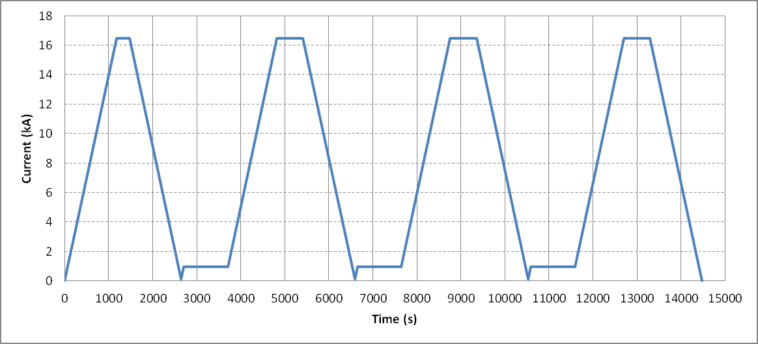
Figure 3: current profile for one accelerator cycle to nominal gradient.

Effect of reset current

- Goals:
  - Measure effect of reset current on persistent current harmonics at injection and subsequent ramp

- Conditions:
  - Use probe #1 at central location (probe #2 data recorded in parallel)

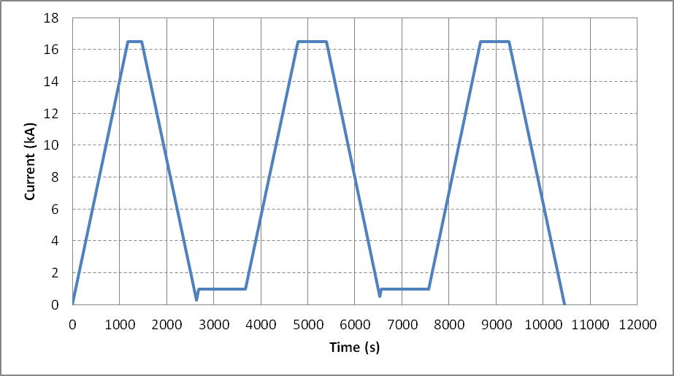
Figure 4: current profile for reset current study

- Measurement cycle (Fig. 4):

- Ramp from 0 to I.nom at 14 A/s,
- Hold for 300 s at I.nom,
- Ramp down to 300 A at 14 A/s
- Hold for 0s at 300 A
- Ramp to I.inj at 14 A/s
- Hold 1000s at I.inj
- Ramp to I.nom at 14 A/s
- Hold I.nom for 600 s
- Ramp down to 500 A at 14 A/s
- Hold for 0s at 500 A
- Ramp to I.inj at 14 A/s
- Hold 1000s at I.inj
- Ramp to I.nom at 14 A/s
- Hold I.nom for 600 s
- Ramp down to zero at 14 A/s

Ramp-rate dependence

- Goals:
  - Measure eddy current harmonics at different ramp rates
- Conditions:
  - Use probe #1 at central location (probe #2 data recorded in parallel)
- Measurement cycle (Fig. 5):

- Perform standard pre-cycle
- Hold 1000 s at I.inj
- Ramp to I.nom at 20 A/s
- Hold 600 s at I.nom
- Ramp to I.inj at 20 A/s
- Hold 600 s at I.inj
- Ramp to I.nom at 40 A/s
- Hold 600 s at I.nom
- Ramp to I.inj at 40 A/s
- Hold 600 s at I.inj
- Ramp to I.nom at 80 A/s
- Hold 600 s at I.nom
- Ramp to I.inj at 80 A/s
- Hold 600 s at I.inj
- Ramp to zero

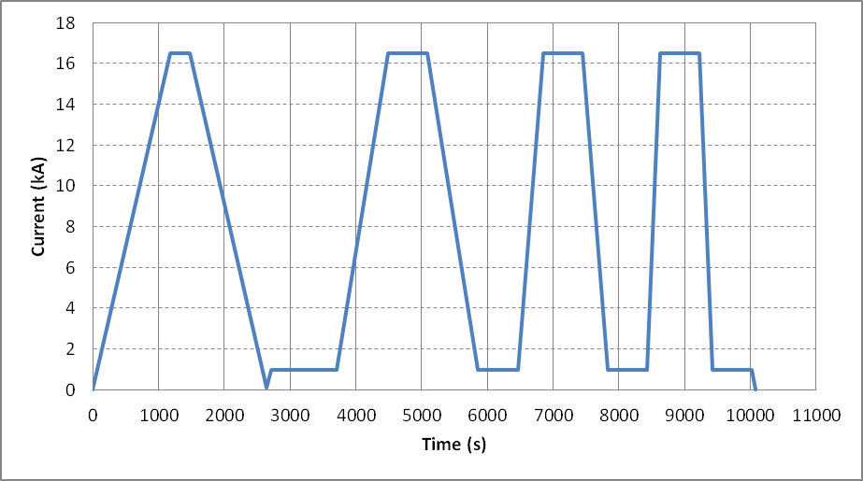
Figure 5: current profile for the ramp-rate dependence study

Reproducibility of accelerator cycle to nominal gradient

- Goals:
  - Assess reproducibility of accelerator cycle

- Conditions:
  - Use probe #1 at central location (probe #2 data recorded in parallel)

- Measurement cycle (Fig. 6):

- Perform standard pre-cycle
- Hold 1000 s at I.inj
- Ramp to I.nom at 14 A/s
- Hold I.nom for 600 s
- Ramp down to I.res at 14 A/s
- Hold for 0s at I.res
- Ramp to I.inj at 14 A/s
- Repeat point 2 to 5 (one time only)
- Ramp down to zero

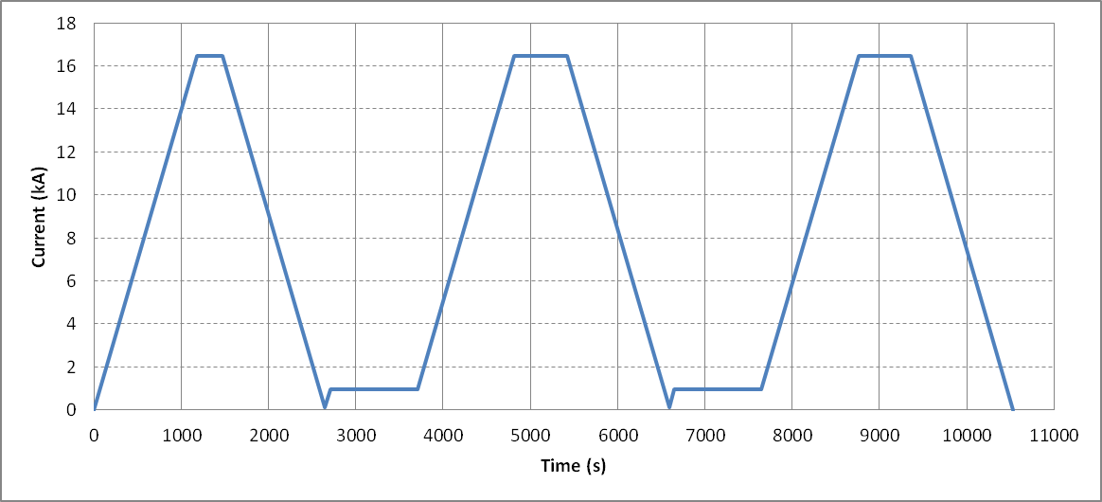
Figure 6: current profile for one accelerator cycle to nominal gradient.

Stair-step measurement

- Goals:
  - Measure static field errors at various current intervals

- Conditions:
  - Use probe #1 at central location (probe #2 data recorded in parallel)

- Measurement cycle:
- Perform standard pre-cycle
- Hold 1000 s at I.inj
- Ramp to I.ult in steps (as defined in Table 3). Ramp rate 14 A/s
- Hold 60 s at each step
- Ramp to 17.9 kA (no measurements)
- Ramp down to I.inj in same steps
- Ramp down to zero

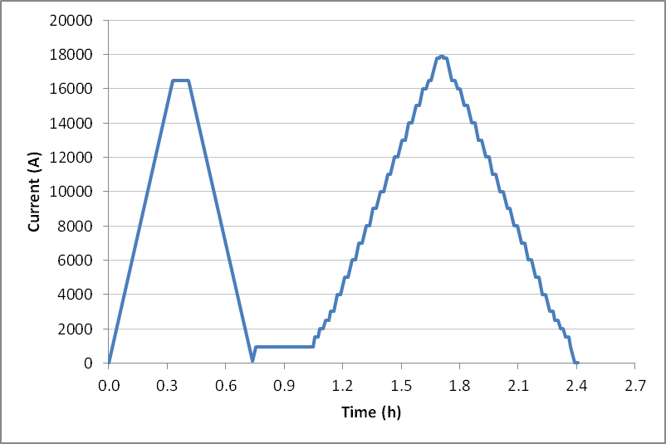

Fig. 7 Current steps for stair step measurement

Table 3 Current steps for stair step measurement
Step # | Current (kA)
1 | I.inj
2 | 1.5
3 | 2.0
4 | 2.5
5 | 3.0
6 | 4
7 | 5
8 | 6
9 | 7
10 | 8
11 | 9
12 | 10
13 | 11
14 | 12
15 | 13
16 | 14
17 | 15
18 | 16
19 | I.nom
20 | I.ult
21 | 17.9

Additional studies with lower priority (estimated time required 2-3 days)

Accelerator cycle to ultimate current

- Goals:
  - Measure central field quality in conditions that approximate the machine cycle to ultimate gradient
  - Confirm operation at I.ult
  - Assess reproducibility from cycle to cycle
  - Assess persistent decay time constant using a longer injection plateau (6000 s)

- Conditions:
  - Use probe #1 at central location (probe #2 data recorded in parallel)

- Measurement cycle (Fig. 8):

- Perform standard pre-cycle
- Hold 1000 s at I.inj
- Ramp to I.ult at 14 A/s
- Hold I.ult for 600 s
- Ramp down to I.res at 14 A/s
- Hold for 0s at I.res
- Ramp to I.inj at 14 A/s
- Hold 1000 s at I.inj
- Ramp to I.ult at 14 A/s
- Hold I.ult for 600 s
- Ramp down to I.res at 14 A/s
- Hold for 0s at I.res
- Ramp to I.inj at 14 A/s
- Hold 6000 s at I.inj
- Ramp to I.ult at 14 A/s
- Hold I.ult for 600 s
- Ramp down to I.res at 14 A/s
- Hold for 0s at I.res
- Ramp to I.inj at 14 A/s
- Ramp down to zero

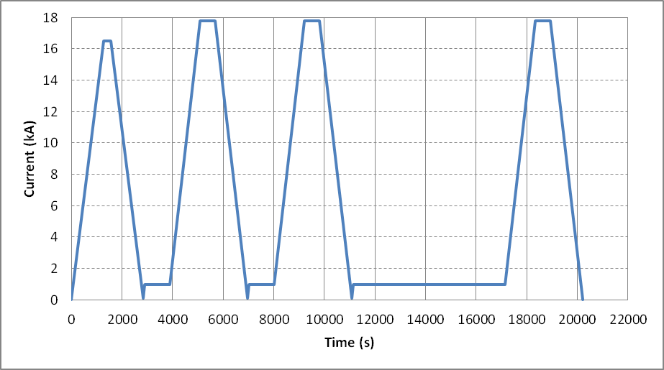

Figure 8: current profile for accelerator cycle to ultimate gradient

Z scan at ultimate gradient

- Goals:
  - Measure field quality variations along the magnet length at I.ult

- Conditions:
  - Longitudinal locations refer to center of probe #1 (probe #2 data recorded in parallel)
  - Longitudinal locations: from z=-853.6 to z=+853.6, every 53.35 mm

- Measurement cycle :

- Perform standard pre-cycle
- Hold 1000 s at I.inj
- Ramp to I.ult at 14 A/s
- Hold 300s at I.ult
- Z-scan at I.ult
- Ramp down to zero

Z scan during warmup and at room temperature

- Allowed current levels as a function of temperature:

  - If the resolution at 10 A is acceptable, the same current will be used for measurements at all intermediate temperatures. To be confirmed after warm measurements in vertical positions.
  - If increased current is desirable, Table 2 shows the expected safe current limits as function of temperature, based on HQ experience. This will be verified for QXF by monitoring the coil strain gauges and voltage.

Table 2 Maximum current for different temperature intervals
Temp. (K) | Current (A)
200 – 295 | ± 15
100 – 200 | ± 20
< 100 | ± 30

- Goals:
  - Measure geometric harmonics at low current as a function of temperature

- Conditions:

  - Default current 10 A. Maximum current as defined in section 6.
  - Longitudinal locations refer to center of probe #1 (probe #2 data recorded in parallel)
  - Longitudinal locations: from z=-853.6 to z=+853.6, every 53.35 mm

- Additional notes:

- Target one measurement soon after the magnet enters the normal state (~ 30 K) to obtain the geometric effect with maximum effect of preload from cooldown.
- External heating to expedite the warmup process should be off before and during the measurements to help reducing temperature gradient along the magnet.

References

- MQXF Coordinate system definition,
http://larpdocs.fnal.gov//LARP-public/DocDB/ShowDocument?docid=1079

