MQXFS1 Protection Studies Plan
Version 1b, 11/11/2015

Contents
1 Protection studies goals and strategy for MQXFS assembly test 1
2 Protection studies overview 3
3 Reference parameters and conditions 3
4 During magnet cool-down 4
5 Protection system check-out 4
6 Before training (30 mΩ dump resistor, no delay; 1.9 K) 5
7 During training 5
8 Reference scenario C.2.a 5
8.1 Minimum power density to quench 5
8.2 Protection heater delays 6
8.3 Fast extraction study 7
9 Protection plan adjustments under scenario C.2.b (magnet reaches ultimate level) 8
9.1 Before thermal cycle 8
9.2 After thermal cycle 8
9.2.1 Quench Integral 8
9.2.2 Failure scenario studies 8
10 Protection plan adjustments under scenario 1 (magnet limited below nominal) 8
11 Measurements during warmup and at room temperature 9
12 References 9

Protection studies goals and strategy for MQXFS assembly test

Different scenarios were developed for the MQXFS1 assembly test [1], depending on the performance level that can be achieved with the existing (non-conforming) coils. The goals and plan for protection studies reflect these different scenarios. Scenario C.2.a (magnet reaches nominal, but not ultimate) will be used as initial reference for the protection plan. Scenario C.2.b (magnet proceeds above ultimate) and C.1 (magnet is limited below nominal) will be treated as variations with respect to the reference plan.

Protection studies are organized according to the potential risk associated with them. For the moment this is simply based on the estimated hot spot temperature that might be achieved. Three ranges are defined based on MQXF design calculations and experience from HQ testing:

- Training: T_{hot}<150 K
- General protection studies: T_{hot}<250 K
- Special protection studies: T_{hot}<350 K

A preliminary estimate of the MIITs associated with these temperature ranges is shown in Fig. 1. These ranges will have to be reassessed during the test, in particular to confirm that the temperature and MIITs during training can actually be maintained below the target values. High MIITs studies (T_{hot}>350K) are not foreseen for this test.

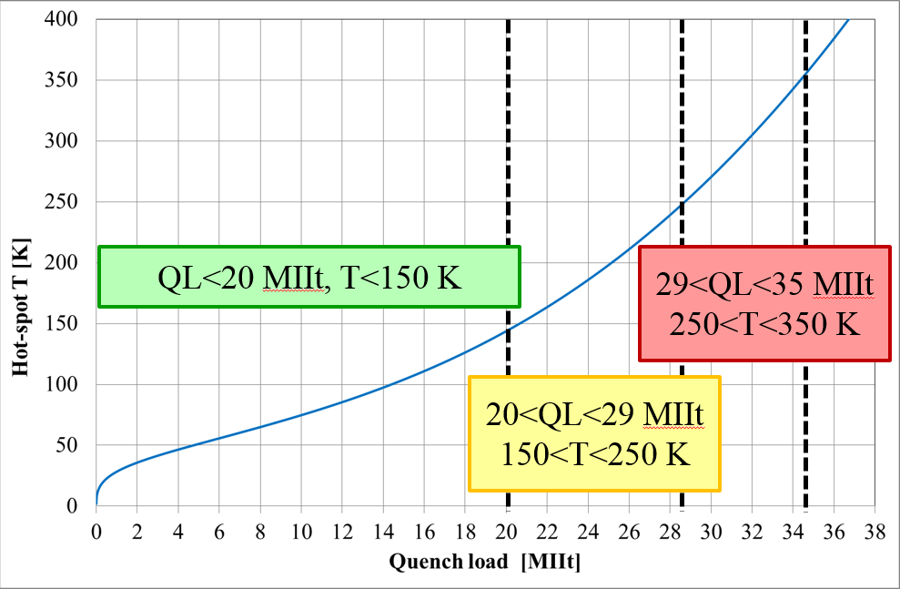

Fig. 1: Defined temperatures ranges and corresponding estimated MIITs ranges
According to this definition, the general protection studies (T_{hot}<250 K) include:

- Protection system check-out (Section 5)
- Pre-training heater performance studies (Section 6)
- Minimum heater power density to quench (Section 8.1)
- Protection heater delays (Section 8.2)
- Fast extraction studies (Section 8.3)

Studies that fall under the special protection studies (250 K<T_{hot}<350 K) include:

- Quench integral (Section 9.2.1)
- Failure scenario studies (Section 9.2.2)

Protection studies overview

This section provides an overview of the planned protection studies for each of the scenario and phases considered in the test plan:
- System and magnet checks below 6 kA
- Preliminary assessment of heater performance at low current
- Finalize heater firing parameters
- Acquire data to compare heater performance before and after training
- During training
- Protection delays are normally set to zero and may be increased up to 10 ms for selected quenches in order to study propagation velocities, provided that sufficient margin can be verified to avoid exceeding the 150 K limit.
- If training proceeds to nominal level, but is limited below ultimate
  - Perform general protection studies up to nominal level
- If training reaches ultimate level
  - Before thermal cycle: complete general studies up to ultimate
  - After thermal cycle: perform special protection studies (hot spot temperature above 250 K)
- If a decision is made to stop training below nominal level
  - Perform a subset of protection studies, compatible with the current level achieve

Reference parameters and conditions

- Currents and corresponding gradients for injection, nominal and ultimate level are specified in Table 1. Short sample estimates (based on weighted average) and RRR from witness samples are provided in Table 2 and 3.

Table 1: reference current levels for MQXFS test.
Current [kA] | Symbol | Gradient [T/m] | Remarks
0.96 | I.inj | 8.5 | Injection level
16.48 | I.nom | 132.6 | Nominal level
17.90 | I.ult | 143.2 | Ultimate level
6.0 | I.lim | 48.8 | Current limit (pre-training)

Table 2: short sample estimates for MQXFS test.
Coil | 103 | 104 | L03 | L05
I_{ss} [kA] @ 1.9K | 21.5 | 21.8 | 22.28 | 21.84
I_{ss} [kA] @ 4.3K | 19.55 | 19.8
I_{ss} [kA] @ 4.5K |  |  | 20.12 | 19.72

Table 3: Coil RRR from witness samples.
Coil | 103 | 104 | L03 | L05
# samples (XS) | 3 | 3 | 6 | 6
RRR - weighted average [*]
RRR - simple average | 176 | 158
RRR - minimum | 164 | 146 | 232 | 347
RRR - maximum | 186 | 172 | 432 | 604
[*] Definition of weighted average

During magnet cool-down

- No measurements foreseen in the first test cycle. For future test cycles, check if it is possible to perform preliminary measurements of coil/segment RRR at this stage, to compare with witness sample results.

Protection system check-out

- Goal: confirm proper operation of protection systems, determine/confirm HFU settings
- Procedure: Set HFU capacitance at 19.2 mF. Fire all heaters gradually increasing the HFU voltage, starting at 200 V until the quench is induced. Measure delay to quench. Check signals for any signs of insulation failures.
- Schedule: Two heater provoked quenches at 3.3 kA (20% nominal current) and 4.94 kA (30% nominal current).

Before training (30 mΩ dump resistor, no delay; 1.9 K)

- Goal: acquire basic data on heater performance on a virgin coil, for comparison with performance after training
- Procedure: Fire one heater circuit with gradually increasing voltage. When quench occurs, measure delay from heater firing to quench start, protect with all other heaters and dump resistor
- Schedule: Four discharges in total: IL heater (half coil) at 20 and 30% of nominal current, and OL high-field heater at 20 and 30% nominal current, using CERN heater strips in coil 103.

During training

- Standard setting: dump configuration: 30 mΩ, HFU settings as determined during provoked quenches, no delays to heaters and dump upon detection of quench
- Monitor MIITs, consider increasing the delays up to 10 ms to study propagation, if sufficient margin can be confirmed

Reference scenario C.2.a

The baseline plan includes general protection studies (with expected peak temperature below 250 K). Reference current levels for these studies are given in Table 4. The 20%, 50%, 80% and 100% points correspond to the ones used for the MQXFS1 mirror test. Points at 10% and 30% (1.65 kA and 4.94 kA) are added for a more complete assessment of the heater performance at low current, which is becoming more critical with the more recently proposed protection schemes in the accelerator.

Table 4: reference current levels for heaters/protection studies
Current [kA] | 1.65 | 3.30 | 4.94 | 8.24 | 13.18 | 16.48
I/I_{nom} | 0.1 | 0.2 | 0.3 | 0.5 | 0.8 | 1.0

Minimum power density to quench

- Goal: Find minimum heater power density needed to start a quench for different current levels (Table 4)
- Procedure: a single heater is fired at gradually increasing power, while the other heaters (and dump) are in protection mode
- Schedule:
  - Repeat the tests for different HFU capacitance values (TBD)
  - Repeat for each heater of one CERN and one LARP coil (specify which) or repeat for both LARP and CERN coils (TBD)

Protection heater delays

- Goal: measure the delay from heater firing to start of quench for different current levels (Table 4) and power density (based on results of 8.1)
- Procedure: Manually fire all heater circuits, measure delay to quench, then trigger 30 mΩ energy extraction (not delayed) to minimize cryogenic recovery time
- Schedule:
  - PH delay as a function of the magnet current. Compare performance of the IL and OL heaters. Assess performance of high-field and low-field OL heaters separately.
  - PH delay as a function of the power density (HFU charging voltage)
  - PH delay as a function of the HFU decay time (HFU capacitance)
  - Reproducibility check for the IL and OL heater delays at different magnet current
  - Reproducibility of results for nominally identical heaters on different coils (also note we have CERN/LARP, but, on one hand, CERN is baseline, on the other, this might be only opportunity for LARP heater tests)
  - Reproducibility check for the IL and OL heater delays with respect to the pre-training values (see section 5)
    - Procedure: Fire one heater circuit, measure delay to quench, protect with all other heaters and 30 mΩ dump resistor not delayed (at T=1.9 K)
    - Four discharges in total: IL heater at 20 and 30% nominal current, and OL heater at 20 and 30% nominal current, using CERN heater strips
Table 5: Proposed current levels and HFU charging voltage and capacitance values
 | Current [kA] and I/I_{nom}
HFU | 1.65 | 3.30 | 4.94 | 8.24 | 13.18 | 16.48
 | 0.1 | 0.2 | 0.3 | 0.5 | 0.8 | 1.0
C=19.2 mF, U=420 V
C=19.2 mF, U=x V
C=19.2 mF, U=x V
C=14.4 mF, U=420 V
C=14.4 mF, U=x V
C=14.4 mF, U=x V
C=9.6 mF, U=420 V
C=9.6 mF, U=x V
C=9.6 mF, U=x V
C=4.8 mF, U=420 V
C=4.8 mF, U=x V
C=4.8 mF, U=x V

Fast extraction study

- Procedure: manually trigger the quench detection, which triggers an energy extraction with a certain value of resistance; no heaters triggered; no quench, or only quench-back, expected
- Discharge at different current levels and with different resistance will provide information about the magnet dynamic behavior and quench back
- For these tests, quench load limited to <20 MIIt (T_{hot}<150 K) and peak voltage limited to <900 V

Table 6: Expected initial current change for the proposed current and energy-extraction resistance values
Peak dI/dt [kA/s] | Current [kA] and I/I_{nom}
 | 1.65 | 3.30 | 4.94 | 8.24
R_EE [mΩ] | 0.1 | 0.2 | 0.3 | 0.5
5 | 0.7 | 1.3 | NO | NO
10 | 1.3 | 2.7 | 5.4 | NO
30 | 4.0 | 8.0 | 16.1 | 20.1
60 | 8.0 | 16.1 | 32.1 | 40.1
90 | 12.0 | 24.1 | 48.2 | 60.2
120 | 16.1 | 32.1 | 64.2 | NO

Protection plan adjustments under scenario C.2.b (magnet reaches ultimate level)

Before thermal cycle

- Complete general studies up to ultimate (add I_{ult} current step to previous studies)

After thermal cycle

- Perform special protection studies (expected hot spot temperature in the 250K-350K range)

Quench Integral

- Quench integral (QI) and quench propagation (from the OL to the IL) study with dump delay of 1000 ms (“no dump” configuration)
- Procedure: Manually trigger quench detection, which triggers all heater circuits, measure delay to quench, measure quench integral, 30 mΩ energy extraction is delayed by 1000 ms and hence does not contribute to magnet protection
- Start with a manual trip at low currents (I/I_{nom}=0.3) without the dump resistor
- Gradually increase the magnet current. Stop testing if the QI is approaching the 35 MIITs (350 K) limit.
- QI study with small dump resistor (5 mΩ)

Failure scenario studies

- Procedure: manually trigger the quench detection, which triggers all heaters but some selected circuits; energy extraction delayed by 1000 ms
- Using the same current levels proposed during quench integral studies
- Three failure scenario
  - 1 OL and 1 IL heaters missing (attached to the same pole)
  - 1 OL heater missing
  - 1 IL heater missing

Protection plan adjustments under scenario 1 (magnet limited below nominal)

- Follow general studies plan, without the current levels above maximum achieved

Measurements during warmup and at room temperature

- RRR for coil segments (need to discuss procedure)

References

- MQXFS1 Test Plan overview,
http://larpdocs.fnal.gov//LARP-public/DocDB/ShowDocument?docid=1079

