MQXFS Magnetic Measurement Plan
Version 2c, 11/11/15

Contents
1 Magnetic measurement goals for MQXFS assembly test 2
2 Facility and rotating probe 2
3 Magnetic measurements overview 2
4 Reference parameters and conditions 4
5 Longitudinal scan at room temperature 5
6 Magnet Cool-down 5
7 Measurements at 1.9 K before training quenches 6
8 Field quality characterization from injection to nominal level (baseline scenario 2A) 7
8.1 Accelerator cycle 7
8.2 Stair-step measurement 8
8.3 Z scan at selected gradients 9
8.4 Ramp-rate dependence 9
8.5 Effect of reset current 10
9 Additional studies to be performed under scenario 2B 12
9.1 Accelerator cycle to ultimate current 12
9.2 Z scan at selected gradients 13
10 Modifications under scenario 1 (magnet limited below nominal) 13
10.1 Accelerator cycle 13
10.2 Stair step measurement 13
10.3 Z-scan 14
10.4 Ramp rate dependence 14
10.5 Effect of reset current 15
11 Z scan during warmup and at room temperature 16
12 References 16

Magnetic measurement goals for MQXFS assembly test

Different scenarios were developed for the MQXFS assembly test, depending on the performance level that can be achieved with the existing (non-conforming) coils. The magnetic measurements goals and plan reflects these different scenarios.

- If progress is limited below nominal level (132.6 T/m)
  - Characterize field quality at low/intermediate field
- If magnet achieves the nominal level but progress is limited below ultimate
  - Perform full field quality study to nominal
- If magnet exhibits good training performance to ultimate level (143.2 T/m)
  - Perform z-scan and accelerator cycle to ultimate
  - Verify reproducibility of harmonics after thermal cycle (no corrections implemented)

Facility and rotating probe

MQXFS will be tested at FNAL Vertical Magnet Test Facility (VMTF). Primary test temperature is 1.9 K. A new anti-cryostat and PCB probe were developed to optimize data quality in the 150 mm aperture. Two probes are integrated on the same board. Radius is 50.5 mm for both. Length is 106.7 mm and 215.8 mm, respectively. These values are close, but not exactly equal to 1x and 2x the nominal cable pitch length (109 mm). In the following, they will be referred to as probe #1 and #2.

Magnetic measurements overview

This section provides an overview of the planned magnetic measurements for each of the scenario and phases considered in the test plan:
- Setup, cool-down, system and magnet checks before training
  - Magnet in cryostat at 300 K
    - Longitudinal scan to confirm assembly data and verify the coordinate system in the vertical position
  - Preliminary magnetic measurements before training (120 mΩ or 30 mΩ dump resistor; 1.9K; I_{max} = 6kA).
    - Z scan of the straight section only at 0.96 kA (injection level) and 6 kA
    - Ramp rate study: 100 A to 6kA at 20, 40 , 60 A/s
- Primary performance assessment
  - Training at 1.9K
    - No magnetic measurements (quench antenna will be in warm bore for all training quenches

- One of the following cases will be selected after the first phase of training

- If a decision is made to stop training below nominal
  - Performance studies up to maximum stable current, and characterization of performance limits.
    - Selected magnetic measurements to maximum stable current
  - Warm up to 300 K
    - Magnetic measurements during warm-up

- If training proceeds to nominal level
  - Perform full set of measurements to nominal level
    - Magnetic measurements at 1.9K (full plan)
      - Geometric harmonics in straight section and ends
      - Persistent-current effect at low field
      - Dynamic effect with cored cable
      - Effect of iron saturation and coil deformation at high field
      - Reproducibility in different ramps
      - Warm-cold correlation
  - Continue training and select one of the following cases

- If a decision is made to stop training below ultimate level
- Performance studies up to maximum stable current
  - Additional magnetic measurements up to maximum stable current
- Warm up to 300 K
  - Magnetic measurements during warm-up
- If training reaches ultimate level
- Performance studies up to ultimate level
  - Complete magnetic measurement plan up to ultimate
- Warm up to 300 K
  - Magnetic measurements during warm-up
- Magnetic measurements during warm-up
- Full thermal cycle
  - Confirm key findings and investigate open question from first TC
  - Detailed plan for second cycle to be developed

Reference parameters and conditions

- Currents and corresponding gradients for injection, nominal and ultimate level are specified in Table 1.
  - Injection level was calculated as follows. G.inj = 132.6/7*0.45 = 8.5 T/m. Low current transfer function is 8.86 T/m/kA (Ref: MQXF design report v7, July 2015), therefore 0.96 kA for 8.5 T/m

Table 1 Reference current levels for magnetic measurements of MQXFS.
Current [kA] | Symbol | Gradient [T/m] | Remarks
0.1 | I.res | 0.9 | Reset level for pre-cycle
0.96 | I.inj | 8.5 | Injection level
6.0 | I.lim | 48.8 | Current limit (pre-training)
16.48 | I.nom | 132.6 | Nominal level
17.90 | I.ult | 143.2 | Ultimate level
21.5 | I.ssl | 171.0 | 1.9K Short Sample Limit

- Nominal ramp rate is 13 A/s. For ramp-rate dependence and AC loss measurements, we use 20, 40 and 80 A/s (as for HQ) in addition to 13 A/s.
  - Quench detection setting for 13 A/s ramp. A specific set of quench detection settings at low/intermediate current allowing a ramp rate of 13 A/s during magnetic measurements may be required. These studies will be selected and verified as part of the system checks phase below 6kA. The setting used for HQ accelerator cycle may be adopted as a starting point.

- An optimized profile for acceleration/deceleration at the beginning and end of each ramp needs to be defined (for each ramp rate) to minimize the impact on the multipole decay and to avoid current overshoot and the resulted ramp irregularity

- Pre-cycle parameters for measurements up to I.nom (or higher). A pre-cycle is applied to put the magnet into a reproducible state prior to the following measurements: accelerator cycle, stair-step measurements and ramp-rate dependence measurements.

  - The pre-cycle is defined as follows:

    - From 0 to I.nom at 13 A/s,
    - Hold for 300 s at I.nom,
    - Ramp down to I.res at 13 A/s
    - Hold for 60s at I.res
    - Ramp to I.inj at 13 A/s
    - [Hold at I.inj is treated as part of the measurement cycle]

  - The pre-cycle needs to be adapted for measurements limited to lower current (measurements performed before training and measurements performed under scenario 1, stop training below nominal). The modified pre-cycle is described in the corresponding sections.
  - For measurements requiring a pre-cycle, the pre-cycle needs to be repeated in the case of a spontaneous quench, prior to completing the measurement.

- The central location will be determined during the warm measurements and confirmed during the system checks phase by matching the transfer function dependence on z to design calculations and similar measurements taken during the magnet assembly.

The following sections describe the individual magnetic measurements to be performed. Section 5, 6, 7, 11 apply to all scenarios being considered. Section 8, 9, 10 apply to individual scenarios as indicated.

Longitudinal scan at room temperature

- Conditions:
  - Magnet placed in the vertical cryostat, before start of cool-down
  - Current: ±10 A
  - Longitudinal locations refer to center of probe #1 (probe #2 data recorded in parallel)
  - Longitudinal locations: from z=-853.6 to z=+853.6, every 53.35 mm
- Goals:
  - Check the measurement system and probe behavior.
  - Determine the probe reference location with respect to the magnetic center, and the reference angle.
  - Compare the room-temperature measurements with those performed during the magnet assembly.

Magnet Cool-down

- No cool-down measurements are foreseen, unless required to check/modify system based on feedback from warm scan. Change of harmonics as a function of temperature will be assessed during magnet warm-up (section 10).

- Allowed current levels as a function of temperature:
  - If the resolution at 10 A is acceptable, the same current will be used for measurements at all intermediate temperatures. To be confirmed after warm measurements in vertical positions.
  - If increased current is desirable, Table 2 shows the expected safe current limits as function of temperature, based on HQ experience. This will be verified for QXF by monitoring the coil strain gauges and voltage.

Table 2 Maximum current for different temperature intervals
Temp. (K) | Current (A)
200 – 295 | ± 15
100 – 200 | ± 20
< 100 | ± 30

Measurements at 1.9 K before training quenches

- Goals:
  - Obtain a minimum set of field quality record before start of training:
    - Ramp at different rates for the dynamic effect
    - Z scan for static harmonics along the bore at selected currents
  - Get preliminary feedback on functionality of new measurement system, allowing some time for analysis/improvement during training
  - Verify the quench detection settings to allow the ramp at 13 A/s from injection to peak current level for magnetic measurements.

- Central harmonics for different ramp rates

- Use probe #2 at central location (probe #1 data recorded in parallel)
- Pre-cycle from 0 to I.lim at 50 A/s, dwell 60s, down ramp from I.lim to I.res at 50 A/s, dwell 60 s, ramp from I.res to I.inj at 20 A/s, dwell 300 s (higher RR may be used if needed)
- Measurement cycle: I.inj I.lim I.inj at various ramp rates. Ramp rate = 20 A/s, 40 A/s, and 60 A/s.
- Dwell for 300 s between ramps
- Current profile for transitions at start and end of ramp TBD
- Complete at I.inj, ready for z-scan

- Longitudinal scans of central section at different current levels

- Can proceed directly after completion of the ramp rate study
- Current levels for z-scan: I.inj, I.lim
- Ramp between levels at 50 A/s
- Dwell 300 s before start of measurements at each current level
- Longitudinal locations refer to center of probe #1 (probe #2 data recorded in parallel)
- Longitudinal locations: from z=-853.6 to z=+853.6, every 53.35 mm

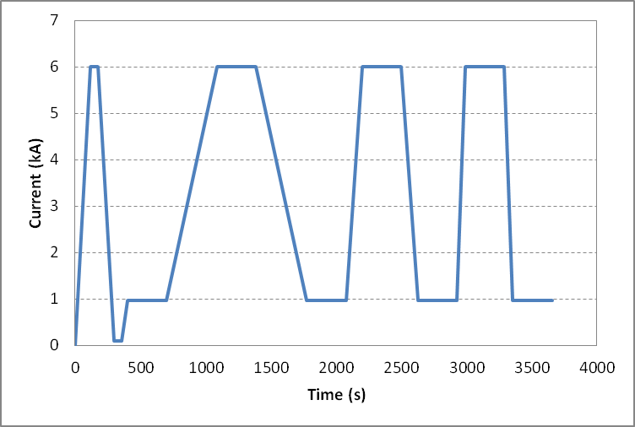
Figure 2: current profile for the ramp-rate dependence before the training quench at 1.9 K.

Field quality characterization from injection to nominal level (baseline scenario 2A)

Accelerator cycle

- Goals:
  - Measure central field quality in conditions that approximate the machine cycle to nominal gradient
  - Assess stability at I.inj and changes in harmonics at the start of ramp
  - Assess stability of operation at I.nom
  - Assess reproducibility from cycle to cycle

- Conditions:
  - Use probe #2 at central location (probe #1 data recorded in parallel)

- Measurement cycle (Fig. 3):

  - Perform standard pre-cycle
  - Hold 1200 s at I.inj
  - Ramp to I.nom at 13 A/s
  - Hold I.nom for 600 s
  - Ramp down to I.res at 13 A/s
  - Hold for 60s at I.res
  - Ramp to I.inj at 13 A/s
  - Repeat point 2 to 5 for a second time
  - Ramp down to zero

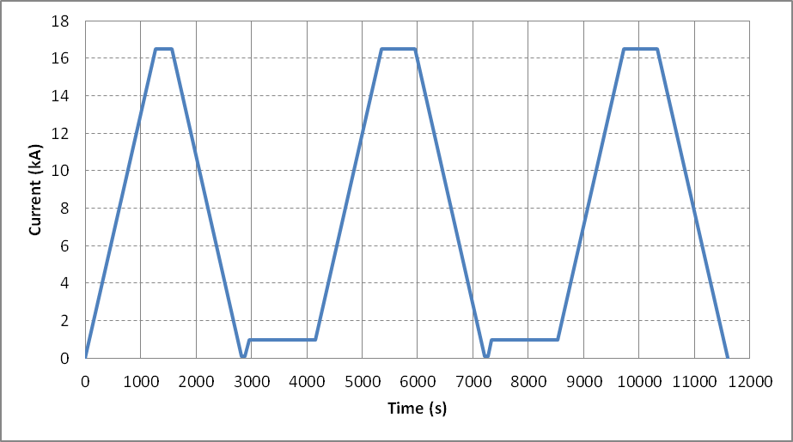
Figure 3: current profile for one accelerator cycle to nominal gradient.

Stair-step measurement

- Goals:
  - Measure static field errors at various current intervals

- Conditions:
  - Use probe #2 at central location (probe #1 data recorded in parallel)

- Measurement cycle:
- Perform standard pre-cycle
- Hold 1200 s at I.inj
- Ramp to I.nom in steps (as defined in Table 3). Ramp rate 13 A/s
- Hold 60 s at each step
- Ramp down to I.inj in same steps
- Ramp down to zero

Table 3 Current steps for stair step measurement
Step # | Current (kA) | Step # | Current (kA)
1 | I.inj | 11 | 8
2 | 1.5 | 12 | 9
3 | 2.0 | 13 | 10
4 | 2.5 | 14 | 11
5 | 3.0 | 15 | 12
6 | 3.5 | 16 | 13
7 | 4 | 17 | 14
8 | 5 | 18 | 15
9 | 6 | 19 | 16
10 | 7 | 20 | I.nom

Z scan at selected gradients

- Goals:
  - Measure field quality variations along the magnet length

- Conditions:
  - Longitudinal locations refer to center of probe #1 (probe #2 data recorded in parallel)
  - Longitudinal locations: from z=-853.6 to z=+853.6, every 53.35 mm

- Measurement cycle :

- Perform standard pre-cycle
- Hold 1200 s at I.inj
- Z-scan at I.inj
- Ramp to I.lim at 13 A/s
- Hold 300 s at I.lim
- Z-scan at I.lim
- Ramp to I.nom at 13 A/s
- Hold 300 s at I.nom
- Z-scan at I.nom
- Ramp down to zero

Ramp-rate dependence

- Goals:
  - Measure eddy current harmonics at different ramp rates

- Conditions:
  - Use probe #2 at central location (probe #1 data recorded in parallel)

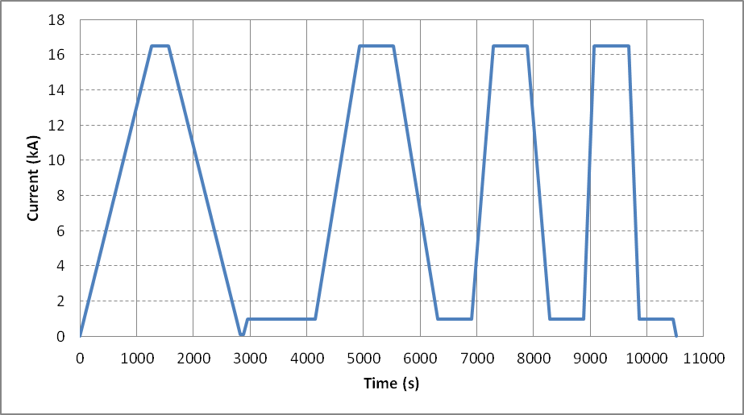
Figure 4: current profile for the ramp-rate dependence study

- Measurement cycle (Fig. 4):

- Perform standard pre-cycle
- Hold 1200 s at I.inj
- Ramp to I.nom at 20 A/s
- Hold 600 s at I.nom
- Ramp to I.inj at 20 A/s
- Hold 600 s at I.inj
- Ramp to I.nom at 40 A/s
- Hold 600 s at I.nom
- Ramp to I.inj at 40 A/s
- Hold 600 s at I.inj
- Ramp to I.nom at 80 A/s
- Hold 600 s at I.nom
- Ramp to I.inj at 80 A/s
- Hold 600 s at I.inj
- Ramp to zero

Effect of reset current

- Goals:
  - Measure effect of reset current on persistent current harmonics at injection and subsequent ramp

- Conditions:
  - Use probe #2 at central location (probe #1 data recorded in parallel)

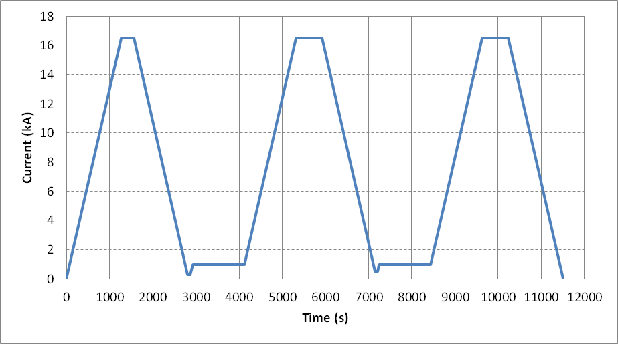
Figure 5: current profile for reset current study

- Measurement cycle (Fig. 5):

- Ramp from 0 to I.nom at 13 A/s,
- Hold for 300 s at I.nom,
- Ramp down to 300 A at 13 A/s
- Hold for 60s at 300 A
- Ramp to I.inj at 13 A/s
- Hold 1200s at I.inj
- Ramp to I.nom at 13 A/s
- Hold I.nom for 600 s
- Ramp down to 500 A at 13 A/s
- Hold for 60s at 500 A
- Ramp to I.inj at 13 A/s
- Hold 1200s at I.inj
- Ramp to I.nom at 13 A/s
- Hold I.nom for 600 s
- Ramp down to zero at 13 A/s

Additional studies to be performed under scenario 2B

Accelerator cycle to ultimate current

- Goals:
  - Measure central field quality in conditions that approximate the machine cycle to ultimate gradient
  - Assess stability of operation at I.ult
  - Assess reproducibility from cycle to cycle

- Conditions:
  - Use probe #2 at central location (probe #1 data recorded in parallel)

- Measurement cycle (Fig. 6):

- Perform standard pre-cycle
- Hold 1200 s at I.inj
- Ramp to I.ult at 13 A/s
- Hold I.ult for 600 s
- Ramp down to I.res at 13 A/s
- Hold for 60s at I.res
- Ramp to I.inj at 13 A/s
- Repeat point 2 to 5 for a second time
- Ramp down to zero

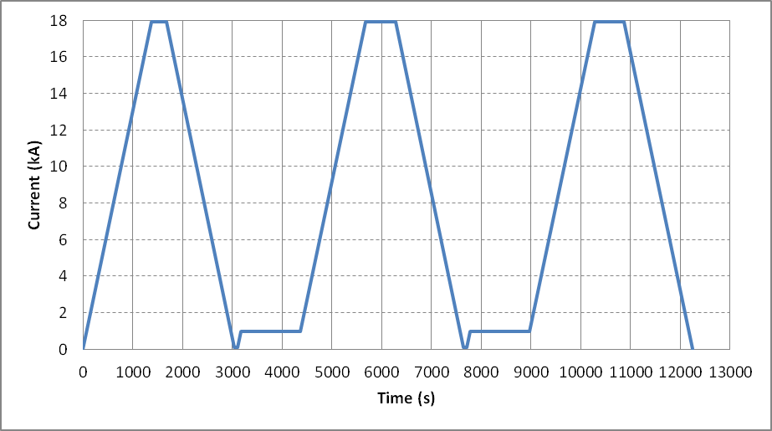
Figure 6: current profile for accelerator cycle to ultimate gradient

Z scan at selected gradients

- Goals:
  - Measure field quality variations along the magnet length at I.ult

- Conditions:
  - Longitudinal locations refer to center of probe #1 (probe #2 data recorded in parallel)
  - Longitudinal locations: from z=-853.6 to z=+853.6, every 53.35 mm

- Measurement cycle :

- Perform standard pre-cycle
- Hold 1200 s at I.inj
- Ramp to I.ult at 13 A/s
- Hold 300s at I.ult
- Z-scan at I.ult
- Ramp down to zero

Modifications under scenario 1 (magnet limited below nominal)

Accelerator cycle

- Not performed

Stair step measurement

- Goals:
  - Measure static field errors at various current intervals

- Conditions:
  - Use probe #2 at central location (probe #1 data recorded in parallel)
  - I.max is defined as the maximum stable current achieved after training (see general test plan)

- Measurement cycle:

- Ramp from 0 to I.max at 13 A/s,
- Hold for 300 s at I.max
- Ramp down to I.res at 13 A/s
- Hold for 60s at I.res
- Ramp to I.inj at 13 A/s
- Hold 1200 s at I.inj
- Ramp to I.max in steps (as defined in Table 3, up to Imax). Ramp rate 13 A/s
- Hold 60 s at each step
- Ramp down to I.inj in same steps
- Ramp down to zero

Z-scan

- Goals:
  - Measure field quality variations along the magnet length

- Conditions:
  - Longitudinal locations refer to center of probe #1 (probe #2 data recorded in parallel)
  - Longitudinal locations: from z=-853.6 to z=+853.6, every 53.35 mm

- Measurement cycle :

- Ramp from 0 to I.max at 13 A/s,
- Hold for 300 s at I.max
- Ramp down to I.res at 13 A/s
- Hold for 60s at I.res
- Ramp to I.inj at 13 A/s
- Hold 1200 s at I.inj
- Z-scan at I.inj
- Ramp to I.lim at 13 A/s
- Hold 300 s at I.lim
- Z-scan at I.lim
- Ramp to I.max at 13 A/s
- Hold 300 s at I.max
- Z-scan at I.max
- Ramp down to zero

Ramp rate dependence

- Goals:
  - Measure eddy current harmonics at different ramp rates

- Conditions:
  - Use probe #2 at central location (probe #1 data recorded in parallel)

- Measurement cycle:

- Ramp from 0 to I.max at 13 A/s,
- Hold for 300 s at I.max
- Ramp down to I.res at 13 A/s
- Hold for 60s at I.res
- Ramp to I.inj at 13 A/s
- Hold 1200 s at I.inj
- Ramp to I.max at 20 A/s
- Hold 600 s at I.max
- Ramp to I.inj at 20 A/s
- Hold 600 s at I.inj
- Ramp to I.max at 40 A/s
- Hold 600 s at I.max
- Ramp to I.inj at 40 A/s
- Hold 600 s at I.inj
- Ramp to I.max at 80 A/s
- Hold 600 s at I.max
- Ramp to I.inj at 80 A/s
- Hold 600 s at I.inj
- Ramp to zero

Effect of reset current

- Goals:
  - Measure effect of reset current on persistent current harmonics at injection and subsequent ramp

- Conditions:
  - Use probe #2 at central location (probe #1 data recorded in parallel)

- Measurement cycle:

- Ramp from 0 to I.max at 13 A/s,
- Hold for 300 s at I.max
- Ramp down to 300 A at 13 A/s
- Hold for 60s at 300 A
- Ramp to I.inj at 13 A/s
- Hold 1200s at I.inj
- Ramp to I.max at 13 A/s
- Hold I.max for 600 s
- Ramp down to 500 A at 13 A/s
- Hold for 60s at 500 A
- Ramp to I.inj at 13 A/s
- Hold 1200s at I.inj
- Ramp to I.max at 13 A/s
- Hold I.max for 600 s
- Ramp down to zero at 13 A/s

Z scan during warmup and at room temperature

- Goals:
  - Measure geometric harmonics at low current as a function of temperature

- Conditions:

  - Default current 10 A. Maximum current as defined in section 6.
  - Longitudinal locations refer to center of probe #1 (probe #2 data recorded in parallel)
  - Longitudinal locations: from z=-853.6 to z=+853.6, every 53.35 mm

- Additional notes:

- Target one measurement soon after the magnet enters the normal state (~ 30 K) to obtain the geometric effect with maximum effect of preload from cooldown.
- External heating to expedite the warmup process should be off before and during the measurements to help reducing temperature gradient along the magnet.

References

- MQXFS1 Test Plan overview,
http://larpdocs.fnal.gov//LARP-public/DocDB/ShowDocument?docid=1079
- MQXF Coordinate system definition,
http://larpdocs.fnal.gov//LARP-public/DocDB/ShowDocument?docid=1079

