Coordinate system for magnetic measurements of MQXF magnet
11/3/2015
J. DiMarco, G. Sabbi, X. Wang
A set of conventions for multipole expansion in the MQXF magnet is defined, including a unique reference frame for magnetic measurements and design calculations, and the magnet orientation within that reference frame. These conventions are based on a similar document for LARP HQ magnet [HQ] and consistent with the field error definitions for the US-built LHC IR quadrupoles [LHC].
- The coordinate system: coordinates, angles, quadrants and octants
A Cartesian coordinate system is used with the x-axis pointing to the right and y-axis pointing upwards, viewed from the lead end (Figure 1). The z-axis points to the reader. The angle increases counterclockwise with 0° on the positive x-axis and 90° on the positive y-axis. The quadrants are numbered counterclockwise with quadrant 1 between 0° and 90° with one magnet coil in a quadrant. Each quadrant is divided into two octants where the coil blocks are located. The octants are named by the quadrant numbers and current polarities.
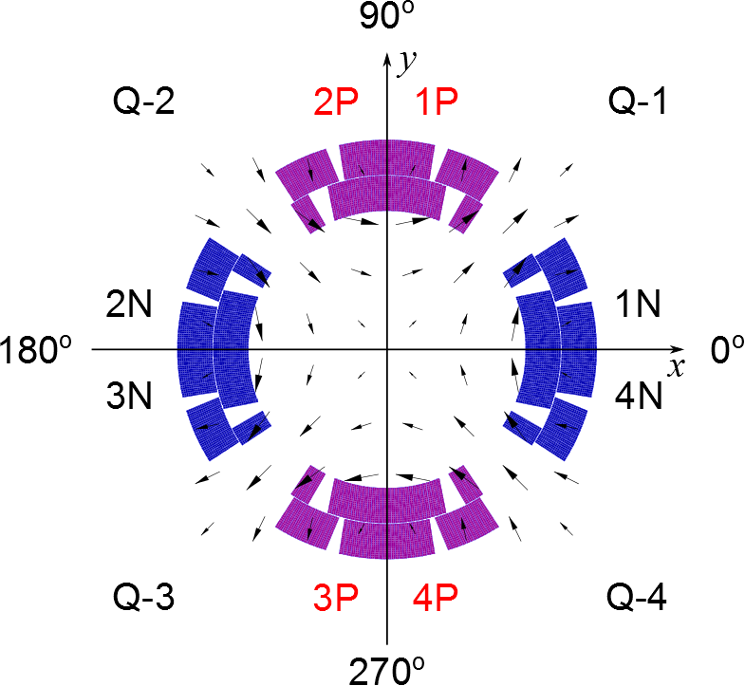
Figure 1 Coordinate system proposed for MQXF as a normal quadrupole, viewed from the lead end. Each quadrant contains one magnet coil. Positive current follows the positive z axis that points to the reader. The current polarity in each octant is given by “P” for positive and “N” for negative.
- Current polarities
To generate a normal quadrupolar magnetic field, the current in each coil block (octant) is defined in Figure 1. The positive current flows toward the reader (the positive direction of z-axis).

- Correlation with magnet assembly
The magnet assembly procedure uses the sectors to define the coil location [Cheng]. Figure 2 gives the correlation between the sectors used for magnet assembly and the quadrants for the coordinate system described here. We can determine the specific coil in each quadrant based on Figure 2.
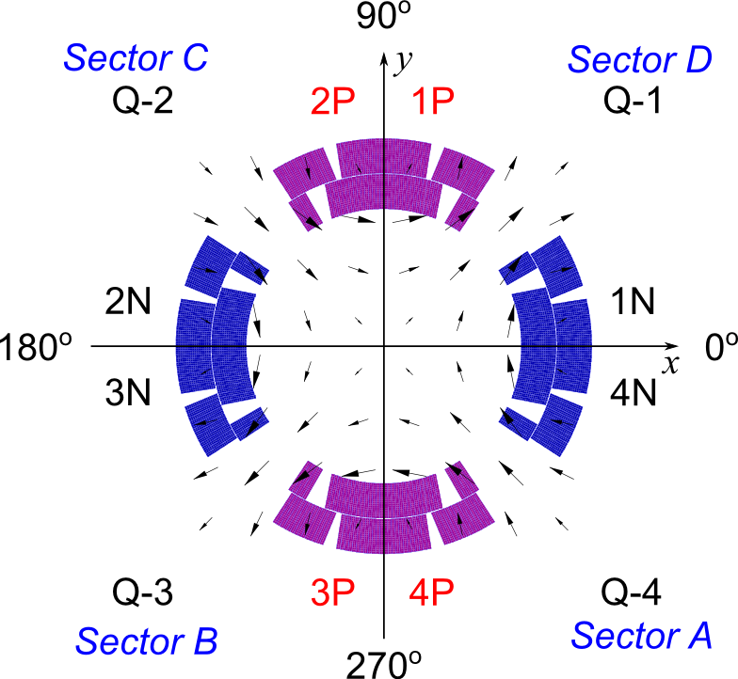
Figure 2 Correlation between the coordinate system for magnetic measurements and magnet assembly, viewed from the lead end.
- Implementation in MQXF models
Figure 3 shows the lead-end view of the MQXF magnet positioned in the coordinate system defined above. The coils in each quadrant (or sector) for MQXF magnets are listed in Table 1.
Table 1 List of coils in each quadrant for MQXF magnet.
Quadrant | 1 | 2 | 3 | 4 | Positive lead | Negative lead
Sector | D | C | B | A | Coil/layer | Coil/layer
MQXFS1 | 104 | 5 | 103 | 3 | 3/outer | 5/inner

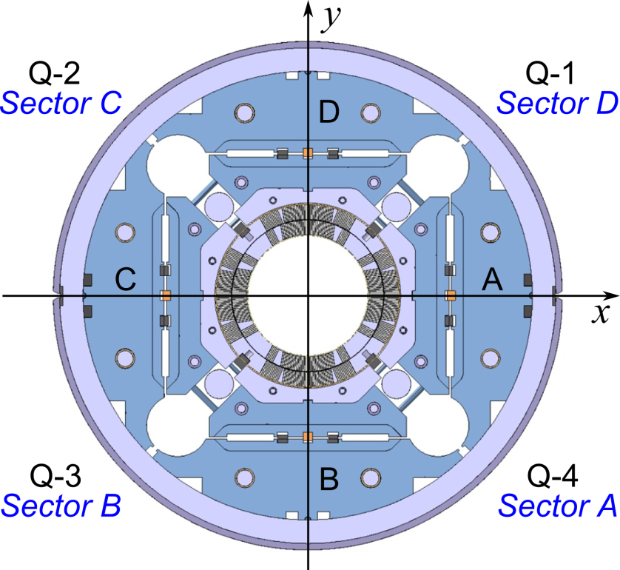
Figure 3 MQXF coils in the coordinate system as defined in Figure 2, viewed from the lead end. The letters A, B, C, D are marked on the magnet yoke.

- References
[HQ] J. DiMarco, G. Sabbi and X. Wang, “Coordinate system for HQ magnet”, LARP-doc-1088-v1.
[LHC] J. DiMarco, M. Lamm, G. Sabbi, and P. Schlabach, “Conventions for HGQ Field Quality Representation”, FNAL report TD-98-034, May 7, 1998.
[Cheng] D. W. Cheng, private communication, 2014.

