Magnetic shim configuration for HQ03a
X. Wang, J. DiMarco, G.L. Sabbi
The application of magnetic shims to correct the field errors have been successfully tested and reported in superconducting accelerator magnets [Gupta96, Sabbi00]. The magnetic shimming was studied for MQXF magnets and the shims in the bladder slots were proposed as an effective tool to correct the field errors at the nominal current level [Hagen14]. In LARP HQ02 magnet, a dummy shim consisted of bronze and carbon steel was successfully fabricated, installed and tested during the magnet cold test. The mechanical stability of the shim was demonstrated and no obvious impact on the magnet quench performance was observed. Here we propose a configuration for magnetic shims to be tested in HQ03a to verify the calculation model for magnetic shims.
Figure 1 shows the non-negligible low-order field errors along the straight section of HQ03a measured at 15 kA, 1.9 K. For example, b₃ varies between -4 to 0 units. On the other hand, the analysis indicates that the full-width shims, i.e., the shims occupy the whole space of the bladder slot, have limited correction capability compared to HQ03a measurements. For example, the correction on the sextupoles is up to ±2.5 units and up to ±0.3 units for the octupoles at 15000 A.
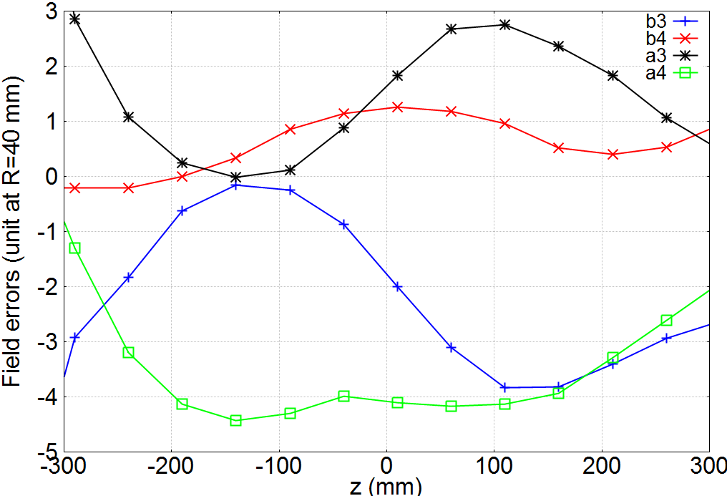
Figure 1 The sextupoles and octupoles along the straight section of HQ03a measured at 15 kA, 1.9 K. The reference radius is 40 mm.
To verify the computational model of the magnetic shims and their impact on the field errors, we propose a configuration to provide a correction +2.5 units on b₃ at 15000 A (Figure 2). Figure 3 compares the measured b₃ (without the shims) and the expected b₃ with the proposed shim configuration.

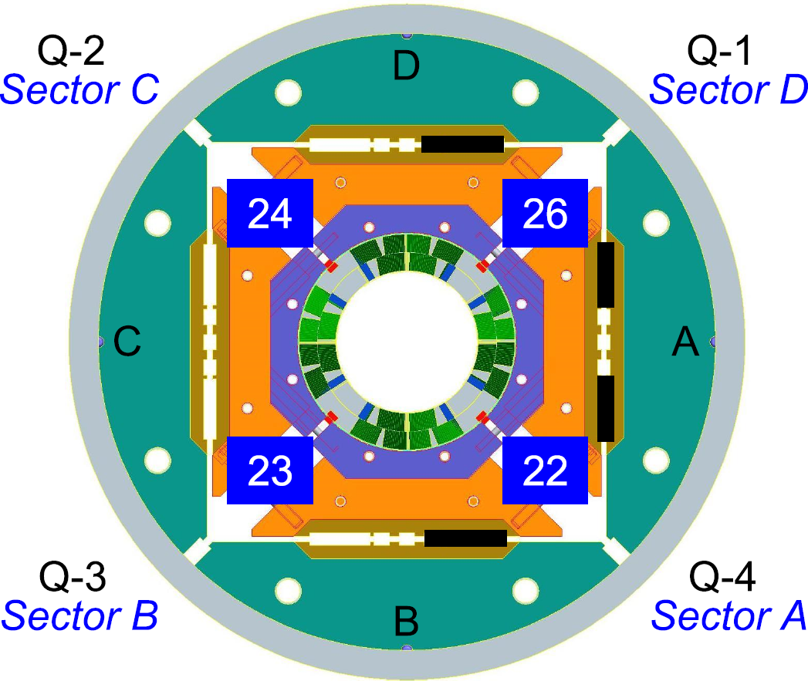
Figure 2 The shim configuration to provide a correction of +2.5 units for b₃.
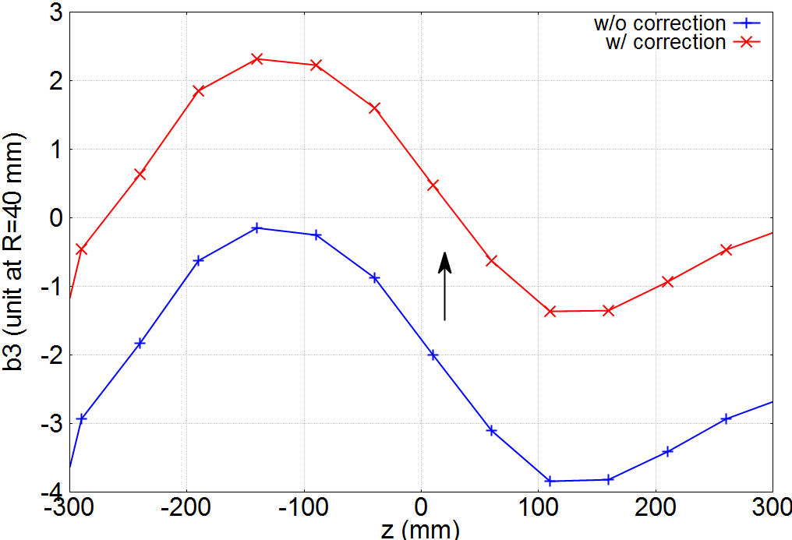
Figure 3 Expected impact on b₃ from the proposed shim configuration.
Reference
[Gupta96] R. Gupta, “Tuning shims for high field quality in superconducting magnets”, IEEE Trans. Magn., 32, pp. 2069-2073, 1996.
[Hagen14] P. Hagen, “Study of fine-tuning field quality in MQXF quadrupole”, LiLumi LHC Milestone Report 36, November 2014.
[Sabbi00] G. Sabbi, J. DiMarco, A. Nobrega, T. Ogitsu, P. Schlabach, J. Tompkins, S. Yadav, “Correction of High Gradient Quadrupole Harmonics with Magnetic Shims”, IEEE Trans. Appl. Supercond., 10(1), pp. 123-126, 2000.

