Proposed US Contributions to LHC High Luminosity Upgrade
February 4, 2013
Eric Prebys, Oliver Brüning, John Fox, Marc Kaducak, Tom Markiewicz, Alex Ratti, Lucio Rossi, GianLuca Sabbi, Peter Wanderer

Executive Summary
In response to the request of the DOE and the recommendations from the 2012 review of the LARP Program, we are submitting a proposal for US contributions to the high luminosity upgrade of the LHC. This proposal has been arrived at in accordance with our previously submitted down-selection plan. We have determined that the proposed US contributions will be (in order of priority):
- Half of the cold masses for the 150 mm aperture Nb₃Sn quadrupoles
- Crab cavity R&D up to the planned tests in the SPS, followed by the construction of the cavities and cryostats for the high luminosity upgrade.
- Development of a high bandwidth feedback system resulting in a functional prototype.
It appears that these projects can fit within the overall budget guidance given by the DOE, given certain assumptions about contributions from CERN and support from General Accelerator Development (GAD) funds. However, expenses early in the project may require CD-3a earlier than FY17 and/or the commitment of additional GAD funds.
Other projects considered for the contribution package that will not be directly supported by LARP are:
- 11 Tesla Dipole: the R&D into this will continue, supported entirely by GAD funds, until a mutually agreed upon stopping point.
- D2 Separator Magnets: This project will be pursued independently by CERN.
- Although it was not one of the candidates in the original document, we have added hollow electron beam halo removal as a possible alternate project, in the event that one of the projects above is not undertaken, if funding increases, or if CERN contributes more to the effort.
These projects can be considered for replacement scope if one of the initial projects turns out not to be viable, or if additional funds become available.

Background
LARP has been coordinating activity at US labs related to the LHC since 2003. Although the program has made numerous contributions to the accelerator, it was always envisioned that R&D done in the program would lead to a limited number of significant construction projects which the US would undertake to help the LHC reach its highest potential luminosity. Planning for such large projects has not been possible until recently, because of uncertainty in the details of the LHC upgrade, particularly following the 2008 startup incident. Over the last year or so, planning for the luminosity upgrade has been formalized under the HL-LHC design study, and LARP has been integrated into this process through active participation in the HiLumi-LHC Design Study. A key milestone was the choice of 150 mm as the aperture for the Nb₃Sn quadrupoles, which was made in June 2012. This allows us to go forward with detailed planning for quadrupole production.
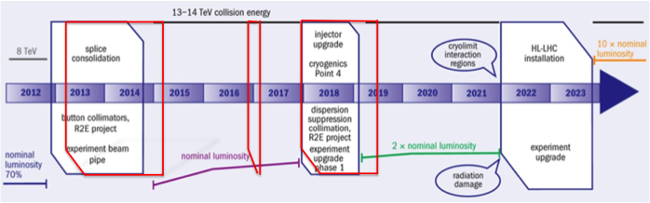
Figure 1 Plan for the next decade, reflecting recent schedule changes. Major upgrade work is done in three long shutdowns (LSs), culminating in LS3, after which the LHC will have a goal of a leveled luminosity of 5x10³⁴ cm⁻²s⁻¹.

Although plans for the upgrade are by no means final, they have progressed to a point where we can begin to plan for the US component. The general schedule for the next decade is shown in Figure 1. Major accelerator work will take place in three “Long Shutdowns” (LSs). The most important upgrades will be the new large aperture quads and likely also crab cavities to compensate for the crossing angle – an effect that becomes much more important at small values of β*.

Budget Guidance and Assumptions
The guidance that we received from the DOE was to assume flat-flat ($12.4M/year) LARP funding for FY13 through FY16 and to assume a total project cost (TPC) of $200M, with CD-3 at roughly the beginning of FY17. This gives a total of $250M, but we would like to continue to devote some fraction of the LARP money during the next few years to accelerator R&D and personnel programs. The exact split will be discussed shortly, but the total available for the project will be on the order of $230M.
In addition, the labs have been directed to make available some amount of general accelerator development (GAD) funds to support this effort. The exact amount has not yet been quantified.
We will see that it will be very difficult to launch any of the candidate projects to meet the LS3 schedule if none of the project funds become available until FY17, so we are assuming that some of the project money will be available prior to that time.

Selection Process

Candidate Projects
The candidate scope was discussed at the LARP review in July 2012. Obvious projects within LARP for inclusion were:
- Final Focus Quadrupoles Based on Nb₃Sn Superconductor. The R&D leading to these magnets has been the cornerstone of LARP since the beginning. We are nominally proposing to build half of the required cold masses.
- Crab Cavities. LARP was an early proponent of crab cavities, and there is hope that the US can contribute to the construction of the cavities for the luminosity upgrade.
- High Bandwidth Feedback for the SPS. This is a project to produce a feedback system for the SPS to combat electron cloud and other instabilities. It has grown out of LARP R&D
- Collimation. LARP R&D which could potentially lead to deliverables includes:
  - The rotatable collimator that has been developed for the last several years by LARP.
  - A halo removal system, using hollow electron beams, a project which was pioneered by LARP, based on studies of electron lenses for beam-beam compensation.
  - Crystal collimators as a replacement for the primary collimators, based on LARP R&D.
The DOE has directed that all significant US contributions to the LHC be coordinated through this project, so we have considered two additional projects, which were initially discussed outside of LARP:
- 11 Tesla Dipoles. These magnets would be used to free up space in the LHC for collimation, because the high field would allow them to provide the same integrated bend field as one of the existing NbTi magnets with a shorter Nb₃Sn magnet.
- D2 Separator Magnets. The D2 magnets are the first twin aperture magnets on each side of the interaction region. As part of the luminosity upgrade, the existing D2 magnets must be replaced with larger aperture versions, still based on NbTi
We initially determined that the collimation projects were not appropriate, since there was no final collimation plan for the LHC; however, because of strong interest at CERN, we have included hollow electron beam halo removal as a possible alternate project in the future.

Cost and Schedule Estimation
We had preliminary cost and schedule information at the review, but it was clear that different standards were used for the different proposals. The first step, therefore, was to use consistent costing methodology for all the projects.
All contacts were given templates with guidance for labor, escalation, and contingency assumptions, and cost estimates were then revised. The updated estimates for cost and schedule are shown in Table 1 along with the proposed CERN contributions.

Prioritization and Selection
Prioritization and selection were done over several meetings of a selection committee, which consisted of:
- Eric Prebys, FNAL, LARP Director
- Tom Markiewicz, SLAC, LARP L2 Manager for Accelerator Systems
- GianLuca Sabbi, LBNL, LARP L2 Manager for Magnet System
- Peter Wanderer, BNL, LARP Representative for BNL
- Lucio Rossi, CERN, Project Coordinator for HiLumi-LHC
- Oliver Bruning, CERN, Deputy Project Coordinator for HiLumi-LHC and LARP Liaison
- Stuart Henderson, FNAL, Head of the LARP Laboratory Oversight Group
- Bruce Strauss, DOE, LARP Program Manager
In addition, Marc Kaducak, FNAL provided project support in the compilation of the cost and schedule. Representatives of the various projects attended the meetings as needed.
Factors considered in the prioritization of the projects included:
- CERN Interest
- Likelihood of being implemented in HL-LHC upgrades
- Exploitation of US expertise
A consensus quickly emerged about the likely scope of the proposal. Considering LARP’s history as a leader in Nb₃Sn, it was taken as axiomatic that production of significant fraction of the quadrupole magnets would be given the highest priority. However, the budget guidance does not allow the US to produce all the magnets. The initial proposal is therefore for the US to produce half of the cold masses: those for the Q1 and Q3. CERN would be responsible for the Q2 cold masses, which might have a double length, as well as all cryostats.
The proposed magnet contribution would use up the majority of the budget in the guidance, limiting prospective additional scope. We discussed reducing the magnet contribution to allow for additional activities, but this was not viewed as desirable by either CERN or the DOE.
For the remaining scope, we selected
- Crab cavity work and cryostat development, leading up to the tests in the SPS, with production of cavities and/or cryostats as allowed within the budget
- Development of a high bandwidth feedback system, up to a functional prototype.

It was decided that the 11 Tesla dipole R&D would continue to be supported by GAD funds at FNAL, up to a mutually agreed upon stopping point. Budgeting for that project is not included in our proposal.
After discussion with CERN, we agreed to include hollow electron beam halo removal as alternate scope if circumstances allow or call for it.
BNL is encouraged to finish the magnetic design of the D2 separators, but at this time we cannot pursue them within this project.
All of these are candidates for inclusion if one of the existing projects is terminated or if additional funds become available.

Table 1: Potential scope considered for US contribution to the LHC. Selected scope is indicated in green. Proposed CERN contributions are shown in orange. It should noted that this table is based on US accounting practices; thus, the numbers in the table will not exactly match the corresponding numbers quoted for the HL-LHC project.

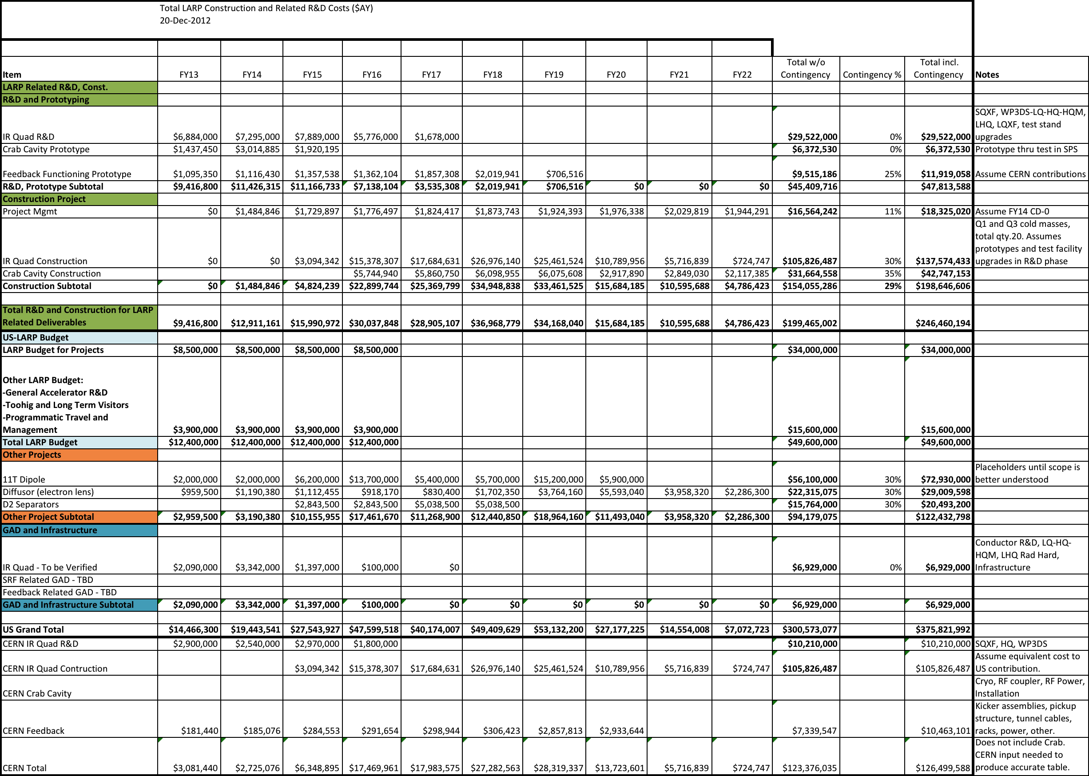

Proposal
The three proposed scope items are discussed in some detail in this section. The overall funding profile is shown as the green portion of Table 1. It should be noted that these figures are based on US accounting practices, and thus do not correspond exactly to the corresponding numbers quoted for the HL-LHC project. In particular, the value of the assumed CERN contributions reflects the estimated cost if this work were carried out in the US.

Nb₃Sn Quadrupoles
The IR Quadrupole project includes design, fabrication and testing of prototypes to demonstrate the required performance, and production of the Q1 and Q3 optical elements, comprising half of the cold masses required for the upgrade.
The development and demonstration of the 150 mm aperture IR Quadrupole design will be carried out by LARP during the next several years. The main goal for this phase is to fabricate and test a series of long prototypes (LQXF) in a time frame that will support key milestones in the construction project approval process (2015-17). The plan includes three LQXF models, entirely built in the US, each one using a set of dedicated coils with two cycles of assembly and test. In addition, a series of short models of the same design (SQXF) will be fabricated and tested by CERN with significant LARP involvement. In particular, the design of both short and long models will be carried jointly by CERN and LARP, and LARP will contribute 6 coils to the short model program. Two magnetic mirror structures will also be fabricated by LARP and used to test the performance of the first short and long coils produced in the US.
In order to achieve these objectives within a flat budget scenario, LARP will have to ramp down other efforts directed at establishing or confirming critical aspects of the technology and design features to be incorporated in the 150 mm models. The cancellation of this part of the program would increase the risk that the 150 mm models may not demonstrate acceptable performance for use in HL-LHC, therefore delaying or preventing the initiation of the IR quadrupole construction project. In order to mitigate these risks, and consistent with recent DOE guidance, LARP has requested that critical aspects of the general R&D in support the 150 mm quadrupole development are performed by the conductor and magnet programs funded under General Accelerator Development (GAD) at LBNL, FNAL and BNL. In addition, LARP has requested that selected infrastructure upgrades required for the LQXF prototypes are provided through a combination of GAD, Laboratory and DOE supplemental funds. Formal agreements on these proposed contributions external to LARP will be required in the near future, to confirm the validity of the IR Quadrupole development plan as currently presented.
The construction phase, to be implemented by the US LHC upgrade project, includes 20 half-length (4 meter) cold masses. Each pair of half-length units will be assembled by CERN in a common cryostat to form one optical element. Producing the IR Quadrupoles as half-length units is necessary to avoid the risks associated with performing a major technology scale-up in parallel with the start of production. The first two cold masses will serve as pre-series units, incorporating additional instrumentation and a more comprehensive test plan (for example, to assess any performance degradation over a large number of cycles or in case of protection failures). The subsequent 16 units will form the core of the production, providing the 8 required optical elements. The last two units will serve as spares.
Coil production is the main driver for the production schedule. In order to fabricate the required number of coils in the allowed time frame (3.5 years) the preliminary plan includes two production facilities working in parallel, with two reaction ovens at each facility. Optimization of the coil production plan may result in significant improvements from the schedule, cost and risk standpoint. Two lines of magnet assembly are assumed, one at each coil production facility, with each half-length cold mass independently supported in a separate mechanical structure. This approach offers more flexibility but requires additional longitudinal space between cold masses, decreasing the effective focusing power of the magnets. A possible alternative to improve the longitudinal compactness is to assemble the two half-length coils in a common structure. It is recommended that a decision among these two options should be performed in the context of the HL-LHC Design Study within the next year so that the quadrupole development and production plan can be adapted in case the common structure approach became the baseline. Finally, the production plan includes testing of all quadrupole cold masses at a single facility in the US before shipping to CERN.
The construction budget includes 30% contingency, which should be adequate considering that full scale prototypes will be fabricated and tested prior to the start of production.

Crab Cavities
The LARP program has been involved with the proposal of crab cavities for the LHC since well before the LHC commissioning. Currently the program is working towards demonstrating the feasibility of a crab cavity in light of both the tight spatial constraints available in the hadron collider, as well as the gradient required. This study has resulted in two promising geometries and one cavity of each design has been built. While these proof of principle cavities are going to be tested and characterized in vertical stands, the collaboration is designing the final cavities and auxiliary systems, which will be integrated into a dedicated cryomodule.
The objective for the present LARP activity is to deliver one complete cryomodule for operation in a beam test in the SPS. This test is meant to demonstrate the crab operation with proton beams, which has no precedent. The scope of this complete system includes the cryomodule, with two cavities including the Helium vessel, mode dampers, tuners and RF pickups. In addition, LARP will provide support to the conceptual design of the RF controllers for the SPS test, based upon the ongoing experience with similar systems developed for the SPX experiment at ANL.

Going into construction, this proposal includes the fabrication of ten cryomodules, one per ring at each side of the two high luminosity interaction points (ATLAS and CMS), plus two spares. This small volume production run still benefits from some economies of scale, in particular leveraging the experience of the current prototyping. Each system assumes that the main RF power couplers will be provided by CERN and integrated in the cryomodules. CERN will also ensure that all other elements of the crab systems, such as RF power and its distribution, RF controls, cryogenics and machine protection, are provided to complete the full system.

High Bandwidth Feedback System
LARP R&D on instability control has focused on overcoming intensity limitations from Ecloud and TMCI ( impedance driven) instabilities. The research has led to techniques and technical components which address intra-bunch instabilities, and has included significant machine measurements and beam dynamics simulations necessary to characterize the possible performance of these feedback techniques.
The project deliverable is a “full-function prototype” instability control system for use at the SPS (and potentially LHC and PS). The major system elements in such a deliverable program include:
- Wideband beam motion Pickups and Kickers (vacuum structures)
- Beam motion receiver and processing electronics
- 4 – 8 GS/sec. digital signal processing system for intra-bunch instability control
- High-power GHz bandwidth RF amplifiers for beam excitation
- System Timing and synchronization system to interface with SPS RF and accelerator systems
- Operator interfaces, control and monitoring software
- Beam diagnostic software and beam instrumentation systems necessary to configure and adjust the instability control system
- Accelerator dynamics simulation models and codes useful to predict stability margins and operational capabilities of the systems.

US and CERN Contributions
The US contribution would be the complete “full-function” instability control system hardware, firmware and software necessary to operate at the SPS (and potentially LHC, PS). This system will have all necessary functions required for SPS operations as part of the HL upgrade. It is considered a prototype that is designed with the knowledge gained from beam tests and studies with the “demonstration system”, and is anticipated to meet all the technical and operational needs of the SPS. The signal processing architecture is reconfigurable and allows continued development of new control methods and diagnostics after the initial construction and commissioning.
The CERN contribution will include the vacuum structures (pickup(s) and kicker(s)) and all tunnel related cable plant. Opportunities continue for collaborations with LNF in all areas, particularly in design/fabrication of wideband kickers.

The high-power RF amplifiers in the system will be joint contributions. The machine measurement and simulation program will continue as a joint US-CERN task.

Funding Issues and Proposed Project Timeline
As one can see Table 1, the proposal is more or less in line with the guidance for the total cost, but all activities require funding in the years before FY17 that is in excess of the LARP funding. In particular, we can compare the row labeled “Total R&D and Construction for LARP Related Deliverables” should be compared to the row labeled “LARP Budget for Projects”, which represents the money we are hoping to allocate out of the flat-flat LARP funding for these projects. Clearly the former exceeds the latter in the next few years.
We therefore propose moving along as quickly as possible with the project execution plan. We propose the following critical decision schedule:
- CD-0: 10/1/2013
- CD-1: 10/1/2014
- CD-2: 10/1/2015
- CD-3: 10/1/2016
where early funds will become available as needed for the project, to help cover the projected shortfall.
It will also be very important to quantify the level of support required and expected from GAD funds, and to establish a means to control and account for these funds. We also feel it is appropriate to commit GAD funds related to SCRF, in addition to magnet R&D funds, although discussion regarding these funds is still ongoing.

2012 DOE LARP Review, https://indico.fnal.gov/conferenceDisplay.py?confId=5409
E. Prebys et al, “Scope Selection Process for US Contributions to the LHC”, LARP-DOC-1069, http://larpdocs.fnal.gov//LARP-public/DocDB/ShowDocument?docid=1069

